Evaluation Form: Community Engagement and Accountability in Cash and Voucher Assistance Kit

You can access the Evalution form here: https://forms.office.com/Pages/ResponsePage.aspx?id=5Tu1ok5zbE6rDdGE9g_ZF8z3SOP8coFDsOkH04XeUaNURVpQRlpaV1lRVVg5WTVGSkxJRTBFSEZIUy4u
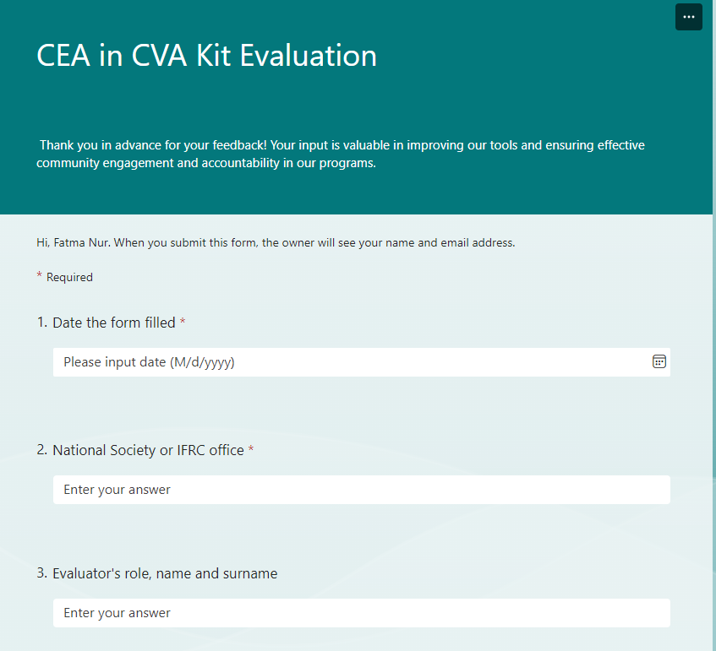

If you prefer to complete the form offline, please answer the questions below and send your completed form to: diana.medina@ifrc.org, fatmanur.bakkalbasi@ifrc.org, and mark.south@ifrc.org
Date of Evaluation:
Evaluator's Name:
Role/Position:
National Society/ IFRC office:
- How clear and understandable did you find the materials provided in the kit?
☐ Clear
☐Somewhat clear
☐ Unclear
- Please explain the parts which were unclear if you selected "unclear" for the previous question.
[Open text field]

- How relevant were the tools and resources to your work in cash and voucher assistance?
☐ Relevant
☐ Somewhat relevant
☐ Not relevant
- Did the kit cover all the necessary aspects of community engagement and accountability in CVA?
☐ Yes
☐ Partially
☐ No
- Which sections of the kit did you find most useful? (Please specify):
[Open text field]

- Which sections of the kit did you find least useful? (Please specify):
[Open text field]

- Did the kit improve community engagement in your CVA programs?
☐ Yes
☐ Partially
☐ No
- Were there any barriers to using the kit effectively? If yes, please specify:
[Open text field]

- What improvements would you suggest for the kit?
[Open text field]

- Do you have any additional comments or feedback?
[Open text field]

Thank you for your feedback! Your input is valuable in improving our tools and ensuring effective community engagement and accountability in our programs.

