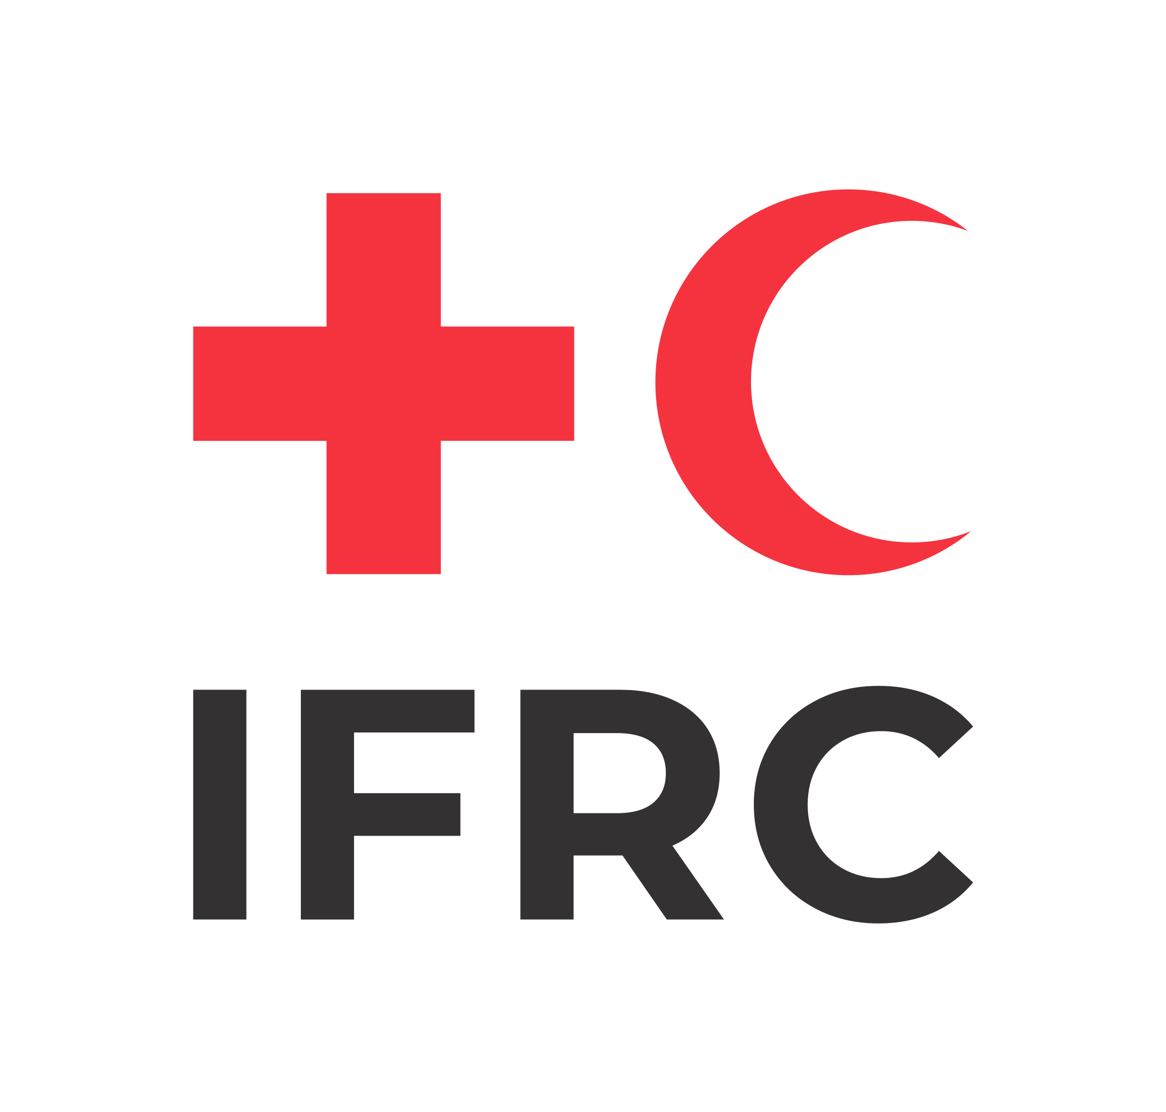
MPOX OUTBREAK:
Guide for RCCE data collection tools
updated on 7th October 2024

The IFRC CEA team has developed and collected data collection tools that can be used in the Mpox response. It is up to National Societies according to their capacities in data collection, to choose which tools they can and want to use.

COMMUNITY FEEDBACK

When National Societies DO NOT HAVE an active Community Feedback Mechanism and low data analysis capacity, the following tools can be used:
- Community Feedback Triage tool developed by LSHTM.
- The IFRC CEA regional team can support in the analysis of the findings.

When National Societies DO NOT HAVE an active Community Feedback Mechanism and have data analysis capacity, tools to be used are:
- Community Feedback Triage tool developed by LSHTM.
- Mpox Coding Framework in French or English.

When National Societies HAVE WORKING Community Feedback Mechanism:
- Standard Community Feedback Data collection form in French or English.
- Mpox Coding Framework in French or English.

RAPID QUALITATIVE ASSESSMENT

When National Societies HAVE QUALITATIVE DATA collection and analysis capacity:
- Focus Group Discussion guide in French or English based on SSHAP question bank.
- Mpox Coding Framework in French or English.
- a PPT format to present the findings, they can use this PPT format as example.

SAMPLING GUIDANCE

You will have a good representation of qualitative data if you adhere to the following:

- Target group: this should directly reflect the research objectives. For example, if the aim is broader, such as understanding general community responses to monkeypox, the target population should represent all affected groups, including different age ranges, genders, and vulnerable populations.

Sample size: conduct 5 – 7 FGD’s and 20 – 30 in-depth interviews, spread across the affected areas. Given that the entire population is often too large to study, a sample is selected to represent the target population. It’s essential that the sample reflects the diversity of the population, including:

  - A range of ages
  - Gender diversity
  - Vulnerable groups (e.g., people with disabilities, marginalized communities)
  - Rural and urban residents

- Sampling strategy: Use purposive sampling to intentionally select participants representing various perspectives within the community. This ensures the data collected provides a comprehensive view of different experiences with monkeypox.

What is a focus group?

6 to 10 people are invited to discuss specific topics in detail. The focus group can bring together people who have something in common. They may share a particular problem or be unable to speak up at larger meetings (for example, IDPs, women, or minority groups), or are people only peripherally involved in the community, such as nomads. It is best not to have leaders or people in authority present is possible and instead interview them separately. Focus group discussions should be conducted separately with men and women and try to use same-sex facilitators, especially for sensitive topics. If possible, try to conduct separate focus groups discussions with adolescent girls and adolescent boys as well Before the focus group discussion begins, the facilitators should introduce themselves and the organization and explain the purpose of the focus group discussion. It is also important to explain how information shared will be used and that it will be kept confidential. The facilitator should also stress the importance of participants giving honest answers, and that future support and aid will not be dependent on them giving positive responses.

Why only six to twelve people? Because in a larger group:
- Speaking time will be restricted and dominant people will speak most
- The facilitator will have to play more of a controlling role
- Some members of the group will become frustrated if they cannot speak
- Participants will start talking to one other rather than to the group as a whole
- The group may stop focusing and start talking about something else

What do you need?
- An experienced facilitator: a native speaker who can lead, draw out the people who are not talking, and stop others from talking too much
- Time to prepare open-ended questions and select focus-group members
- One, sometimes two, people to note in writing what is said
- A common language
- A quiet place where the group will not be overheard or interrupted
- To sit in a circle and be comfortable
- Ground rules: everyone has a right to speak; no one has the right answer; please don’t interrupt
- Permission from the group to take notes
- About one to one-and-a-half hours and some refreshments

What happens?
- The facilitator makes sure everyone has a chance to speak and that the discussion stays focused
- The note-taker writes notes
- At the end of the session, the facilitator gives a brief summing up of what has been said in case someone has something to add
- The facilitator checks that the written record has captured the main points and reflected

Which topics to discuss?
- Introduce the theme & purpose of this discussion (why do you want to hear the opinion from communities and what will happen with this information?)
- Before asking specific questions, ask about the background of the participants to understand whether they represent all community members or only a specific group (such as only male community leaders)

Rules for facilitator
- Ask open questions, such as how, what, where, why as much as possible, especially to clarify or to check understanding. Do not judge people who speak; accept what they say;
- Avoid leading statements and questions; questions should guide the discussion rather than solicit direct answers from each of the participants;
- Avoid dominating the discussion; ask simple questions and only one question at a time;
- Steer the group towards analyzing the causes of the identified issues/problems/ risks, the skills they have at their disposal to resolve them, and the role of the community in developing solutions;
- Ensure time for participants to raise their own questions and concerns;
- Ask the participants which of the issues raised they consider to be the most important.

