Group exercise: INTRODUCTION TO CEA – BUS SERVICE SCENARIO

Facilitator Notes (Participant Handout Below P 7/8)

Overview of this group exercise
Time: | 45 minutes
Purpose: | To help participants understand the purpose and importance of community engagement using an everyday, non-humanitarian, scenario of poor customer service by a bus company
Format: | Group and plenary discussion based on a scenario handout
When: | Day one – morning
Materials: | - One participant hand out per group  - Facilitator notes below to help you guide the discussion  - Flip chart paper and pens for each group

Instructions to run this group exercise
- Give each group a copy of the participant handout ‘. Intro to CEA_Bus service group exercise_Participant’ and ask them to read it in their groups. As a group they need to answer the 3 questions at the bottom of the scenario and write their answers on a flipchart. They should allocate one person to report back during plenary (30 mins)
- Ask one group to feedback per question, then ask if other groups had anything different and use the discussion points below to highlight anything groups did not consider. Close the group exercise by asking one or two people to share what they learnt from this exercise (15 mins)

The marshrutka service scenario
Around 45 passengers, including children and elderly people, are waiting at a marshrutka stand to take the only marshrutka to Goris, which is four hours away. The marshrutka only comes once per day. It’s a snowy January and road accessibility has been unpredictable due to snow and ice.

While the road is open today, it was closed yesterday due to road conditions and it is unclear whether the road will be open the next days. The marshrutka arrives three hours late, forcing the passengers to wait outside in the cold. In addition to the passengers with tickets for today, passengers with tickets from yesterday are also waiting anxiously at the station. When the marshrutka arrives, the passengers surge on to the marshrutka and their luggage is crammed inside and even tied on top. As the marshrutka only has seating capacity for 20 it is very over-crowded and many people are left outside. A woman with four young children talks quietly to the driver to see what she can do to get a seat.

But the marshrutka does not depart. The driver tells the passengers that it will leave within 10 minutes, but the marshrutka remains at the stand for another two hours. Eventually the marshrutka starts its journey, but some passengers begin to cough and others open the windows. It is very cold and everyone begins to yell. One of the passengers, an old man, shouts at the driver and threatens to hit him. The driver shouts back at him and stops the marshrutka.

This scenario was developed by: Goldan Gomara (from World Vision in Sri Lanka) for HAP. For more information see www.hapinternational.org
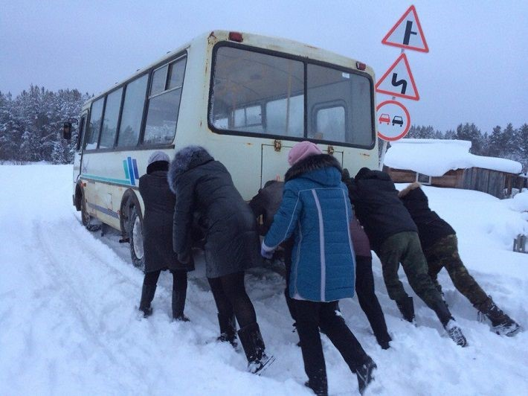
Questions for group discussion – answers on a flip chart

What caused the situation?

How it could have been prevented?

What are the similarities between this situation and Red Cross Red Crescent work in communities?

Discussion points
Q1. What caused the situation?
- The marshrutka company did not consult passengers about their needs and expectations, so they don’t understand what people need
- Poor quality service – the marshrutka is late and overcrowded, with no sheltered place for passengers to wait
- Lack of up-to date reliable information – for example about when the marshrutka would leave, reason for the delays, what customers can expect from the company
- There is no means for people to complain about the service, so the only way they can make their needs heard is by shouting and threatening violence
- The driver’s approach (his skills, behaviour, and attitude) to dealing with his ‘customers’, for example not providing updates on the situation and shouting at passengers
- There is only one marshrutka service, so passengers have no choice. This creates a power imbalance between the passengers (who need to travel) and the marshrutka service (who provide the only service)
- No consideration for how to support more vulnerable groups, such as the woman on her own with four young children
- Cultural aspects, for example, culture of being patient; despondency to situation (i.e., this is how it works, things won’t change etc); hesitant to complain for fear of speaking out against ‘authority’ figures
- Lack of monitoring, e.g., does the company know what time the marshrutka left, number of passengers, passenger views of the service.

Q2. How could it have been prevented?
- Proper assessment of passenger demand and needs should have been carried by the marshrutka company, including more vulnerable groups (elderly, people with children), so they could provide adequate services to meet the needs
- The community should have been consulted on the type of service they would like to receive
- Accurate, timely, relevant information should have been provided, for example arrival times, reasons for delays etc
- Driver should have been trained on customer service, so he can speak to customers with respect by explaining what is happening and listening to their concerns
- The marshrutka company have a staff code of conduct governing how they treat customers, which is signed and understood by all staff
- The marshrutka company should commit to providing a quality service to its passengers, for example reducing delays, providing a comfortable service etc
- Better planning, such as a ticketing system, would help prevent the marshrutka becoming overcrowded and signal level of demand to the marshrutka company
- Planning in advance how to meet the diverse needs of different groups, for example families with young children or babies, older people, people with disabilities etc. For example, by providing priority seating or early boarding for these groups
- The marshrutka company has a functioning complaints and feedback system that responds to and acts on customers’ complaints
- A monitoring system is in place to measure punctuality and issues.

Q.2: What are the similarities between this situation and Red Cross Red Crescent work in communities?
- Insufficient resources - We also provide services to communities, but often there are insufficient resources to meet people’s needs and tough choices need to be made on who is helped and in what way.
- Not understanding the needs – weak assessments or poor community consultation can lead to us providing goods or services which don’t really meet people’s needs, especially in emergencies when time is pressured. This can damage our relationship with communities, affecting our access and acceptance.
- Not understanding the different needs of different groups - different people and groups have different need and priorities. For example, in the marshrutka scenario some people may prioritize getting from A to B, whereas for others the comfort of the journey may be equally or more important. This includes understanding how people’s vulnerabilities may affect their needs, for example the needs of the elderly man or the woman with young children may be different from those of a young single man.
- Poor communication – not providing timely, accurate and relevant information to communities about who we are and what we are doing, and when there are delays or challenges, can lead communities to lose trust in us, or have unrealistic expectations about what we can deliver.
- No opportunity to ask questions or make complaints – not having a system to listen and respond to concerns or complaints can cause frustration, and even lead to threats or violence. This damages our relationship with communities and means we miss opportunities to make important improvements to our work.
- Power imbalance - there is a power imbalance between the ‘users’ (communities) and the service providers (us). This can create the risk of exploitation where staff or volunteers can abuse their position and ask for money or services in exchange for goods and services. For example, in the marshrutka service scenario, the driver could have asked the woman with the young children for extra payment or sexual favours to get a seat.
- Lack of choice - often communities also don’t have a choice in who they receive help from, we may be the only agency providing support in their area. This can sometimes lead to communities (and even our own staff and volunteers) to believe they should be grateful for the support provided, even if it does not meet their needs or is provided in a respectful way.
- Costs to end users – accessing our services may also result in costs for communities, often in the form of time that could be spent doing other activities. For example, time is needed to travel to and wait at distribution points.
- Deciding what to monitor – in the marshrutka service scenario, should the company monitor the number of passengers, the length of the journey, or customer satisfaction? In our work, we often monitor the quantity of what we do (# of items provided, people trained etc), but like the marshrutka service scenario this does not tell us whether we met peoples’ needs or they were satisfied with the quality of support provided. Communities should be consulted on what success means to them and then form part of monitoring process to check their levels of satisfaction with services provided.
- Lack of learning – this is probably not the first time the marshrutka has been late. Similarly, humanitarian organisations often repeat the same mistakes by failing to learn from past learning.

Group exercise: INTRODUCTION TO CEA

Participant handout

The marshrutka service scenario
Around 45 passengers, including children and elderly people, are waiting at a marshrutka stand to take the only marshrutka to Goris, which is four hours away. The marshrutka only comes once per day. It’s a snowy January and road accessibility has been unpredictable due to snow and ice.

While the road is open today, it was closed yesterday due to road conditions and it is unclear whether the road will be open the next days. The marshrutka arrives three hours late, forcing the passengers to wait outside in the cold. In addition to the passengers with tickets for today, passengers with tickets from yesterday are also waiting anxiously at the station. When the marshrutka arrives, the passengers surge on to the marshrutka and their luggage is crammed inside and even tied on top. As the marshrutka only has seating capacity for 20 it is very over-crowded and many people are left outside. A woman with four young children talks quietly to the driver to see what she can do to get a seat.

But the marshrutka does not depart. The driver tells the passengers that it will leave within 10 minutes, but the marshrutka remains at the stand for another two hours. Eventually the marshrutka starts its journey, but some passengers begin to cough and others open the windows. It is very cold and everyone begins to yell. One of the passengers, an old man, shouts at the driver and threatens to hit him. The driver shouts back at him and stops the marshrutka..
This scenario was developed by: Goldan Gomara (from World Vision in Sri Lanka) for HAP.

Questions for group discussion – answers on a flip chart

What caused the situation?

How it could have been prevented?

What are the similarities between this situation and Red Cross Red Crescent work in communities?

