Community Engagement and Accountability Case Study
Zimbabwe Red Cross Leveraging Community Feedback to Enhance Public Health and Drought responses
This case study focuses on Zimbabwe Red Cross Society (ZRCS) efforts to prioritise community members in the Chiredzi, Binga, and Mwenezi communities during public health responses to COVID-19 and measles, as well drought from January to June 2022. The National Society (NS) foregrounds the importance of feedback and community engagement in fulfilling its mission. By fostering strong relationships, actively listening to feedback, and responding to communities’ needs, ZRCS is better able to achieve its mandate, continuously improve its services and positively impacts the lives of people.

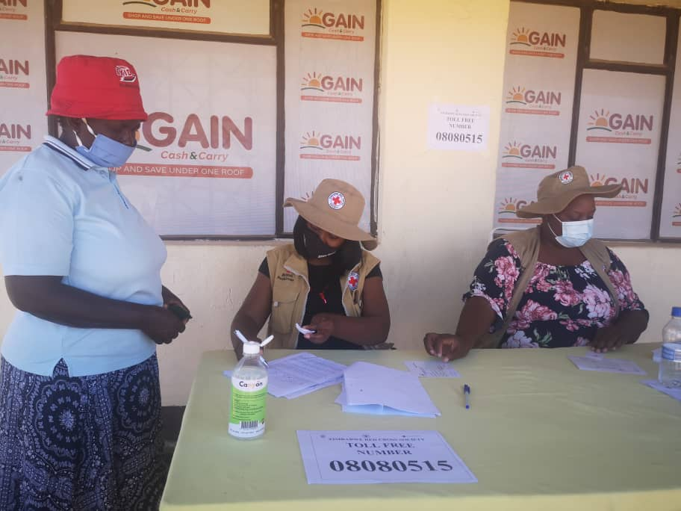 | 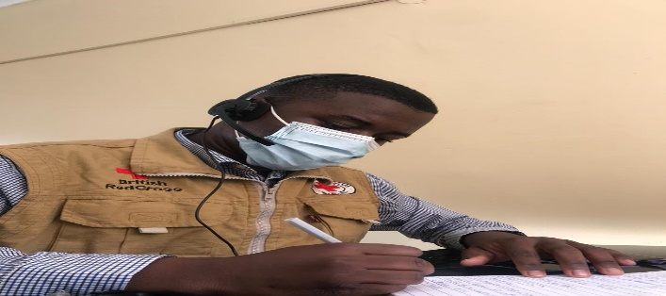
Figure 1: ZRCS helpdesk team receiving feedback and a ZRCS intern answering calls on the toll-free line

Introduction
Communities in Binga district, Matebeleland North province, requested the ZRCS to activate an Early Action Protocol (EAP) to mitigate anticipated drought-induced food insecurity, despite the absence of drought conditions at the time. The EAP was duly launched and ZRCS staff prioritised community engagement and accountability (CEA) approaches, particularly increasing community participation and feedback, as part of the response.
The approach, which aimed to position communities’ feedback at the core of the design of the response, was implemented from 1 January to 30 June 2022. The NS had, however, been collecting feedback from communities since setting up a toll-free line in 2020, which allowed community members to communicate essential information and seek assistance. American Red Cross and International Federation of Red Cross (IFRC) were involved as partners in this initiative. Notably, the partners used data from the community feedback mechanism to inform a successful Disaster Response Emergency Fund (DREF) request for measles. Although the feedback strategy was hampered by a few challenges, among them limited resources affecting the ability to achieve full coverage to more hard-to-reach areas and nationally across all ZRCS projects, this case study emphasises the benefits of collecting community feedback for more effective and people-centred humanitarian responses.

Community engagement to collect community feedback
Zimbabwe Red Cross Society recognised the importance of strengthening community ownership and resilience by gaining deeper understanding of community member’s context, structures, and needs to ensure that the NS could design and implement more effective programmes and operations. Community engagement and accountability approached were also helpful for building trust, access and acceptance of ZRCS teams by communities. The feedback data collection strategy supported ZRCS teams to fulfil the NS’ auxiliary role and contributed to strengthening the Movement-wide commitment to CEA.
Zimbabwe Red Cross teams used proactive strategies like exit surveys, post-distribution monitoring, beneficiary satisfaction surveys, online links for volunteers, focus group discussions (FGDs), key informant interviews (KIIs), and community meetings to collect feedback. Face-to-face interactions such as FGDs, community meetings, and direct interactions with volunteers and branch chairpersons emerged as the most popular methods of sharing feedback and built trust, because they rely on personal connections between Zimbabwe Red Cross personnel and the community members.
Teams also applied reactive strategies such as suggestion boxes, a toll-free line, face-to-face interactions with volunteers and branch chairpersons, helpdesks used during distributions, social media platforms, and call-in radio sessions. While these channels were available for community members to provide feedback, they were relatively less popular compared to face-to-face interactions. The use of suggestion boxes was relatively limited as due to some accessibility challenges for community members as they needed to physically submit feedback at a set location. The popularity of other reactive mechanisms such as social media platforms and call-in radio sessions varied from community to community, based on factors like internet accessibility and community members' prior use of platforms.
The feedback data collected by ZRCS teams were systematically analysed and shared. Data were recorded on a specially designed feedback form and categorised into observations, rumours, perceptions, praises, and questions. Quantitative data was analysed using Excel and Statistical Package for Social Sciences (SPSS). Thematic analysis was applied to assess qualitative data. A dedicated team of five interns analysed and interpreted the data, supervised by the NS Project Monitoring Evaluation and Reporting (PMER) and Community Engagement and Accountability (CEA) officers. Detailed reports were prepared and shared with HQ technical teams, provincial managers and district coordinators, management team members, and partners, ensuring transparency and accountability.
Nationally, Zimbabwe Red Cross collaborates with the Ministry of Health and Child Care (MOHCC), International Federation of Red Cross (IFRC), Risk Communication and Community Engagement Working Group (RCCE WG), and the Community Engagement and Accountability (CEA) Working Group to ensure timely responses and messaging based on evidence from communities.
Feedback trends on public health
COVID-19
Zimbabwe Red Cross teams gathered valuable insights from analysed community feedback. Firstly, they found that certain members of Apostolic sect churches (the second largest ministry in Zimbabwe) expressed that they preferred to vaccinate their children at night. This inclination stemmed from fear of victimisation or backlash from their communities due to their religious beliefs; ultra-conservative sects discourage members from seeking medical care, including childhood vaccinations. Women cannot make decisions about their children’s medical care without permission from a male guardian. Zimbabwe Red Cross teams responded by rolling out religion-sensitive vaccination outreach programmes and messaging to address this particular concern and ensure discreet access to immunisation services for this specific group.
Zimbabwe Red Cross volunteers and Ministry of Health community health workers coordinated to address stated concerns of the Apostolic sect church members which were contributing to their vaccine hesitancy. They conduct targeted social mobilization campaigns during daytime, utilising Red Cross volunteers who were trained in risk communication and community engagement (RCCE) techniques to increase understanding of the benefits of immunisation. They visited households and spoke directly with community members about the importance of childhood vaccinations, addressing fears, concerns and misconceptions as they were shared.
District | Reached households | Targeted households | Reached households % | Average households/day
Binga | 50,065 | 66,500 (190 volunteers x 7days x 50 households) | 75% | 37
Mwenezi | 60,191 | 73,500 (210 vol x 7 days x 50 households) | 82% | 41
Chiredzi | 63,325 | 108,500 (310 vol x 7 days x 50 households) | 58% | 29
Totals | 173,581 | 248,500 rounded to 250,000 | 70% | 36
Table 1: Number of households reached with targeted RCCE for COVID-19 vaccination against targets
Red Cross teams also engaged community and religious leaders and influential men and women, encouraging them to support and promote childhood vaccinations among Apostolic sect members. By emphasising the significance of immunisation for the health, well-being and survival of children, the teams aimed to influence community leaders' perspectives towards good health-seeking behaviour, including COVID-19 vaccination uptake. These efforts contributed to addressing misconceptions, leading to increased vaccination rates, particularly during night-time sessions.

Figure 2: COVID-19 feedback types received from communities.
Another perception identified was that some individuals believed that COVID-19 had disappeared, influenced by the relaxation of infection prevention and control measures and lockdown regulations before Christmas 2021 and into 2022. This misconception underscored the importance of continuous RCCE efforts to reinforce the ongoing presence of the virus and the ongoing need for preventive measures, even as movement restrictions and mask mandates were loosened. Encouragingly, many community members expressed appreciation for the significant efforts made by ZRCS teams in continuing to educate them about COVID-19 and responding. This acknowledgment of the positive impact of the interventions implemented by the NS motivated personnel to keep their finger on the pulse of communities through enhanced communication and participation.
Revealed that ultra-conservative
apostolic sects discourage members from seeking medical care.

Measles

During the response, ZRCS teams quickly learnt that there was a common misperception among community members that only children could contract the disease. This finding spotlighted the importance of launching targeted awareness campaigns to educate communities about who was susceptible to contracting measles and the importance of vaccinating people of all ages. Communities in Chiredzi and Mwenezi district, Masvingo province, asked ZRCS for additional support to address sanitation gaps in their area, demonstrating their understanding of the importance of adequate water, sanitation and health (WASH) infrastructure and their trust in the NS to assist them.

Notably, some members of the Apostolic sect churches in Chiredzi changed their reluctance to be vaccinated after experiencing the devastating effects of measles and being exposed to ZRCS social and behaviour change communication initiatives aimed at increasing their knowledge and influencing their attitudes and practices to avoid infections and seek care. One family, despite their religious beliefs, eventually sought medical intervention after losing seven out of fifteen of the children to measles. This tragic incident served as a turning point, emphasising the importance of vaccination and the potential for shifting attitudes within their religious community.

Feedback trends on drought response
Recognising communities’ vulnerability to drought-induced food insecurity, communities in Binga urged ZRCS to activate an EAP, despite the absence of an existing drought at the time. Although the seasonal outlook indicated normal to above-normal conditions, residents of Binga still requested early distribution of drought-tolerant seeds in a proactive approach to mitigate potential future impacts and safeguard their food production capabilities. By advocating for early access to seeds, communities aimed to enhance their resilience to prolonged dry spells and safeguard their food security.
Through engaging with the communities, however, ZRCS teams discovered that some people underreported their food and livestock stocks intentionally to meet the eligibility criteria for food assistance. This finding supported the importance of conducting thorough assessments and ensuring transparent and fair distribution of resources to avoid unintended consequences and promote equitable access to support. To address this issue and uphold transparency and fairness in resource distribution, ZRCS teams implemented a comprehensive set of quality assurance processes aimed at promoting accountability, discouraging misrepresentation, and safeguarding assistance to those who genuinely met the eligibility requirements. The following strategies were implemented:
- Verification and validation: ZRCS teams established rigorous verification and validation processes to ensure the accuracy of reported information. This included on-site visits, interviews, and cross-referencing data with other available sources. By conducting robust checks, ZRCS aimed to verify the reported stocks and validate the eligibility of community members independently and accurately.
- Community engagement and participation: ZRCS actively engaged with community members, fostering their participation in the assessment and selection processes. This involvement created a sense of ownership and responsibility within the community, emphasizing the importance of accurate reporting. Through collaborative efforts, ZRCS sought to create an environment of transparency, where community members understood the significance of genuine need and fair distribution.
- Whistle-blower mechanisms: ZRCS implemented confidential reporting mechanisms to encourage community members to report suspected cases of misrepresentation or fraudulent behaviour. These mechanisms provided a safe and secure channel for individuals to share information without fear of retribution. ZRCS aimed to create an atmosphere that deterred dishonest practices and ensured the integrity of the resource distribution process.
- Continuous monitoring and evaluation: ZRCS incorporated regular monitoring and evaluation practices to assess the effectiveness of implemented measures. This involved analysing data, conducting feedback sessions, and soliciting community input. By consistently monitoring the processes, ZRCS could identify any gaps for areas for improvement, and adjust strategies accordingly to maintain fairness in and integrity of programmes.
ZRCS emphasised the importance of accurate reporting and consequences of misrepresentation by actively communicating and clarifying the eligibility criteria to community members. This approach sought to foster a culture of trust, ensuring that assistance was provided to those who genuinely met the eligibility requirements while avoiding unintended consequences caused by attempts to circumvent the eligibility criteria.

Figure 2: showing Drought response mechanisms proffered by the Binga communities in anticipation of drought.

Lessons learned
Several valuable lessons were learnt, which will guide future interventions and approaches:
COVID-19 & Measles
- Flexibility of ministry of health personnel: It is important for Ministry of Health officials and personnel, who take the lead in vaccination programmes, to be flexible when dealing with groups known to be hesitant to accept vaccination. They should be prepared to work at any time, including at night if necessary, and go to where vulnerable groups are to ensure that every child is vaccinated. This flexibility will contribute to overcoming barriers to access and ensuring comprehensive coverage.
- Concurrent mass awareness: Simultaneous mass awareness campaigns on different mediums can help to increase the acceptance and uptake of vaccinations. Increasing information disseminated about the importance and benefits of vaccinations can enhance community understanding and acceptance, leading to higher vaccination rates.
- Mobile vaccination clinics: The deployment of mobile vaccination clinics is necessary to cater to communities that must travel long distances. By bringing vaccination services closer to these communities, NS can contribute to reducing the burdens on individuals and improve accessibility to immunisation, helping to increase national figures.
- Strong monitoring and verification: ZRCS recognised the importance of implementing robust monitoring and verification systems to ensure that the correct targeted populations and recipients of assistance were confirmed before distributions. Teams found random sampling methods to be helpful for enhancing the accuracy and integrity of distribution processes.
- Interpersonal communication: Interpersonal communication proved to be the most effective method of reaching communities with targeted information and facilitating two-way communication, which in turn fostered better understanding, trust-building, and the exchange of vital information.
- Engagement with religious leaders: The engagement of religious leaders played a significant role in advocacy efforts and gaining buy-in from key stakeholders at the local level. Their support and endorsement helped strengthen community participation and acceptance of interventions.
- Resource mobilisation for food assistance: National Societies need to engage in proactive resource mobilisation to support food assistance initiatives. In addition to providing immediate relief, consideration should be given to distributing seeds to promote sustainable food production by communities.
Drought Response
- Weather information communication: Timely and accurate weather information communication is crucial for agricultural activities. By providing communities with alerts on dry spells and other weather patterns, National Societies can assist them to make informed decisions and adopt appropriate agricultural practices.
These lessons learned will guide ZRCS teams to refine strategies, improve coordination with stakeholders, and implement more effective and comprehensive interventions to address identified needs and challenges faced by communities we serve.

Next steps
Following the successful implementation of the feedback strategy, ZRCS recognises the importance of continuing to engage with communities in meaningful ways. The lessons learned from this experience will serve as a foundation for future community engagement, ensuring that feedback mechanisms are integrated into ongoing programmes for enhanced and sustained impact. To maintain and strengthen trust and relationships with the community, the National Society will continue to prioritise the active participation of community members by ensuring their voices are heard and acted upon. This may involve enhancing existing community structures or establishing new ones to facilitate feedback channels and promote transparency and accountability.
Investment in training and capacity building for staff and volunteers will be key to equipping them with the needed skills and knowledge for effective community engagement and feedback collection. Recognising that communication is an iterative process, ZRCS teams will continue to monitor and evaluate their engagement with communities. This will enable the identification of areas for improvement and ensure that feedback is effectively utilised to inform decision-making and drive programmatic changes.
The National Society is committed to upholding the Do No Harm principle, which emphasises the importance of minimising negative impacts that may arise from interventions. This includes actively assessing and addressing potential risks, power imbalances, and unintended consequences that could arise from feedback processes. By carefully considering the ethical implications of their actions, ZRCS ensures that engagement with the community is done in ways that promote the well-being and dignity of individuals and avoids any harm.

Contact information
For more information on this case study please contact
Zimbabwe Red Cross: Lovemore Nemerai, Planning, Monitoring, Evaluation and Reporting Officer, lovemoren@redcrosszim.org.zw: +263775686653

