MALAWI RED CROSS CEA CASE STUDY
The following case study follows the KatiKati initiative which is an SMS based initiative for collecting community feedback that was piloted in a number of African National Societies, including Malawi Red Cross.

Introduction
What is KatiKati? The Malawi Red Cross Society (MRCS) Help Desk was created in April 2020 with funding from the Swiss Red Cross to provide information and support to volunteers during the global COVID-19 pandemic until December 2021. The Help Desk was led by the National Society Planning, Monitoring, Evaluation & Reporting (PMER) team, which was also responsible for Community Engagement and Accountability (CEA), including the collection, analysis, and use of community feedback to improve responses. The Help Desk team received and handled feedback from volunteers and community members via the mediums of email, WhatsApp messages and a toll-free telephone number calls. The Help Desk typically received 20 calls a week and 15 queries via WhatsApp before the introduction of the KatiKati initiative. KatiKati is an initiative between Africa’s Voices Foundation (AVF), a United Kingdom (UK)-registered charity and non-profit organisation based in Kenya, and a UK-based technology company, Lark Systems, that developed a one-on-one SMS conversation platform to allow organisations to deploy human-led conversations with constituents, members and communities to strengthen engagement and accountability channels, build stronger and more trusted relationships and effect social change. Launched in 2020, KatiKati helped AVF address urgent concerns, questions, rumours, misinformation and stigma during the COVID-19 pandemic. The initiative was a partnership between (MRCS) and Katikati. Malawi Red Cross received support from the International Federation of Red Cross (IFRC) Africa Regional CEA team and the Netherlands Red Cross Society 510 team, which funded the pilot project for 12 months.

Community engagement approach
Community members sent SMS messages to an advertised short code which AVF team members, using the KatiKati platform, triaged and thematically labelled. Once triaged, the messages were either responded to on a one-on-one basis using standardised responses or escalated urgently for a response by senior management. In its first pilot in Kenya, KatiKati handled SMS from over 5,500 individuals between March and June 2020 using standardised World Health Organization (WHO) and government-authorised COVID-19 messages. It subsequently handled tens of thousands of interactions in Kenya and Somalia. Following this pilot, Africa’s Voices Foundation and Larks Systems expanded their scope to working with other organisations to deploy KatiKati.
When Malawi RC adopted KatiKati, it was integrated into the Help Desk and efforts were made to identify a mobile service providers and secure funding as the first phase of operationalising the SMS-driven initiative and ensuring that there would be no cost for the end-user. Malawi Red Cross volunteers were trained on standard COVID-19 messages and how to communicate with community members. The volunteers were then trained on how to send messages to the toll-free SMS short code –1134 – for the attention of the Help Desk team. The volunteers used their personal phone numbers which were added into KatiKati. KatiKati was working well as there would be feedback from community members on COVID-19.
The KatiKati platform was also used to tackle rumours, especially rumours pertaining to COVID-19 vaccines. The Help Desk worked beyond its purpose and the Malawi Red Cross team received feedback on issues pertaining to disaster management (DM), sexual and gender-based violence, and child safeguarding, including concerns about an increase in child marriage. The platform allowed for anonymous submissions, which helped to uphold the confidentiality of community members who shared feedback and submitted reports.

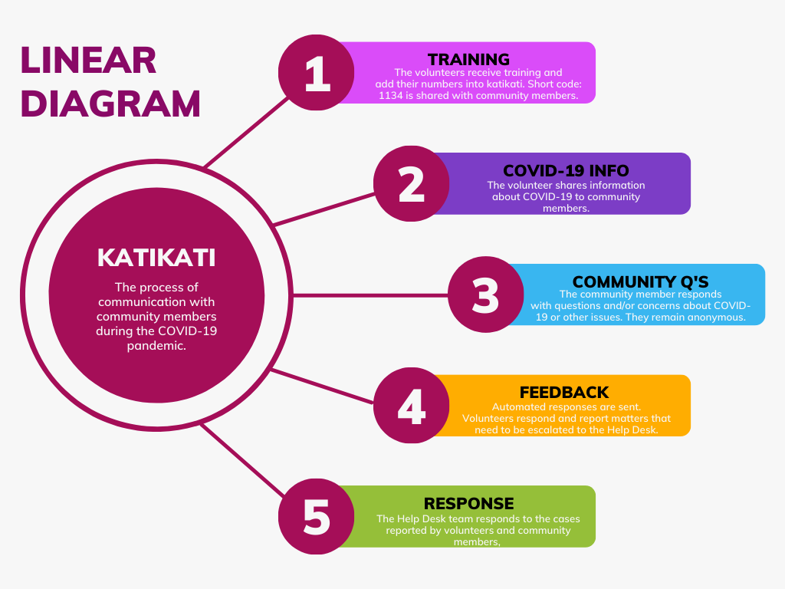
The team aimed to increase their volunteer feedback and participation as well as encourage positive behaviour change among communities to contribute to efforts to prevent and manage COVID-19 infections. The KatiKati initiative was implemented during a time where telephonic communication was all that people could rely on, as the COVID-19 pandemic was at its peak and national lockdowns had physical distancing regulations which impacted contact between people.
KatiKati gave MRCS the ability to handle many one-on-one digital conversations in Chichhewa with their volunteers via a free and accessible Two-way short message service (SMS) short code.
Through the initiative, 1,249 volunteers were informed about COVID-19 and other information (issues of child marriage, sexual and gender-based violence); 11,075 messages were sent to volunteers; 1,820 comments and questions were received from volunteers; 100% of these questions were responded to. There was a 25% response rate of volunteers to questions and 55 conversations were escalated for urgent attention and successfully resolved. The average time for Malawi Red Cross to resolve an escalated issue was 23 hours 41 minutes and the Help Desk team spent an average of 30 minutes a day on the Help Desk.
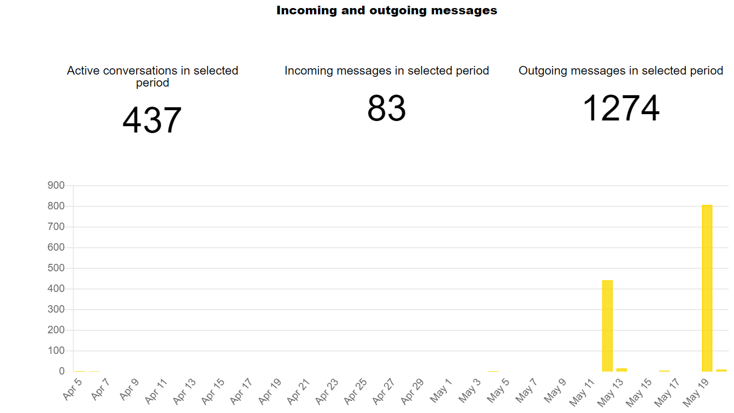
Figure 1.1: Graph showing outgoing messages (mass texts sent periodically). Other replies invisible due to scale)

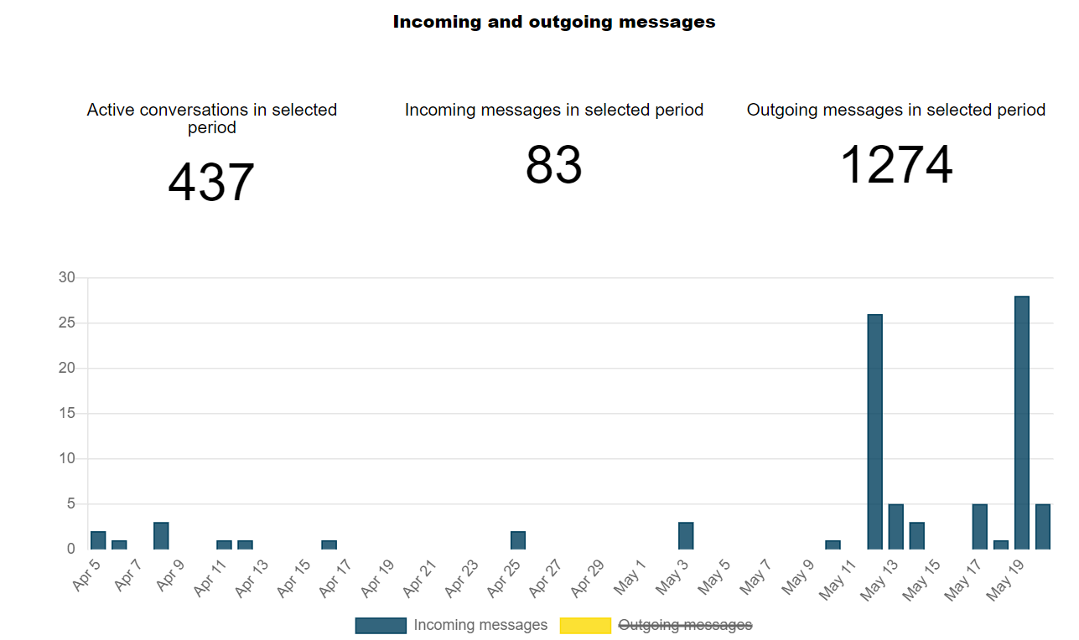
Figure 1.2: Graph showing incoming messages. (High response rate due to response from mass messaging)

SOME COMMON ISSUES COMING THROUGH KATIKATI
ISSUE | RESPONSE | SUGGESTION
Where are COVID-19 services being offered in my district? | Follow up | Set up a system to know which hospitals are providing COVID-19 services
What is COVID-19 booster vaccine? | Explained that is a 3rd jab after complete vaccination | -
Is Malawi administering booster vaccine? | Yes | Disseminate more info on boosters
Where can booster shot be administered? | Vaccination centers | -
Appreciation of information | - | -
COVID-19 questions | Provided appropriate info based on WHO, MoH e.t.c | Provide more information especially emerging issues
Who is eligible to get vaccine? | Everyone from age 12 and above | Provide more information
How many times should booster vaccine be received? | Once | Sensitization on booster
COVID-19 update request | Provided update | Provide COVID-19 updates monthly to volunteers via KatiKati

What are the rumours about Covid-19?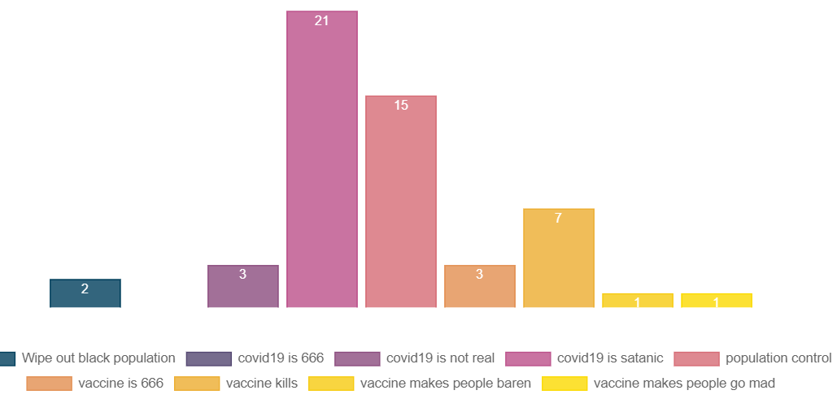
Figure 1.3: Demonstration of the rumours that were reported on.

Challenges
The Help Desk team initially experienced challenges with obtaining a short code and collecting numbers from community members. Funding challenges plagued the initiative for much of the duration of implementation, resulting in the SMS fees not being paid on time sometimes. Another challenge faced by the National Society was the fact that some of the volunteers were not aware of the platform, and some were, Accessibility was only available for the volunteers who had phones and were able to operate them. It was not easy to educate some people on the availability of the platform due to comprehension abilities.
Additionally, another challenge that was faced was the ability to reach community members while the COVID-19 pandemic and the regulations were strict and limited movement within the country. The regulations limited the National Society CEA team’s ability to send information that was life-changing for the community members. Therefore, engaging with community members allowed for there to be a flow in communication from the community members with the volunteers from Malawi Red Cross which meant that the community members could be aided and assisted based on the needs they communicated.
However, there are other feedback platforms that Malawi Red Cross uses. There are suggestion boxes and door to door outreach programmes. Sometimes there are community meetings and Focus Group Discussions (FGD). There are toll free lines which are supported by an audit free company where the line is anonymous. These other feedback platforms demonstrate Malawi Red Cross Society’s ability to collect feedback beyond the Katikati initiative.
Katikati created a space to ask questions, get individual volunteers’ feedback and respond to concerns. The team could also interpret the responses, add tags to them and analyse the different responses.

Added Value to the National Society
Through the use of the platform, insights into the challenge of under-age marriages and weather reporting in different communities were looked into. The appreciation of volunteers was high and there was a positive Help Desk experience. The platform was impactful, and the national society had a reliable addition to their feedback system (in addition to the existing feedback collection mediums). The National Society was able to offer an open, accessible and remote channel for volunteers to share their feedback. The National Society was able to identify and address sensitive concerns, complaints, and rumours quickly, as well as hold human one-on-one conversations with 1,000+ volunteers with a small team. Finally, the National Society was able to encourage volunteer participation, ask questions and gain insight from them in real-time.

Next steps
The NS will build on the findings by increasing the KatiKati outreach to volunteers to a target of 5,000 volunteers from the previous 1,249. This will be achieved by expanding KatiKati to other projects since previously the main targets were districts that were funded by ECHO 6,5 projects. As such, expanding to other projects will ensure that the 5,000 target will be met.
Community engagement activities will integrate the KatiKati element to ensure that volunteers (new and old) are aware of the 1134 tollfree line. Currently, through other activities where volunteers are engaged, they are made aware that MRCS has a toll-free line. This will ensure easy adoption by volunteers especially new to the toll-free line to embrace the platform.
The NS also will make KatiKati its primary feedback system with not only volunteers but also communities due to its speed and convenience. This will not replace other feedback systems but will be part and parcel of the existing feedback systems. Feedback will also not be limited to covid19 feedback but will be extended to other areas such as cholera and other diseases. Building on lessons learnt, KatiKati will also champion anonymous reporting, prevention of sexual exploitation and abuse (PSEA) and fraud, which were not primarily targeted, as covid19 feedback was the priority.
The NS will build a Societal dashboard and also integrate KatiKati into the dashboard accessible by staff on non-sensitive issues. Such information will be important for understanding communities and use that information for proper response. This will also be integrated with community feedback.

Contact information:
For more information on this case study please contact:
Malawi Red Cross: Patrick Phiri, Head of Planning, Quality and Learning, Email: pphiri@redcross.mw; patrickphiri24@gmail.com. Phone: +265 888777080; 992625072

