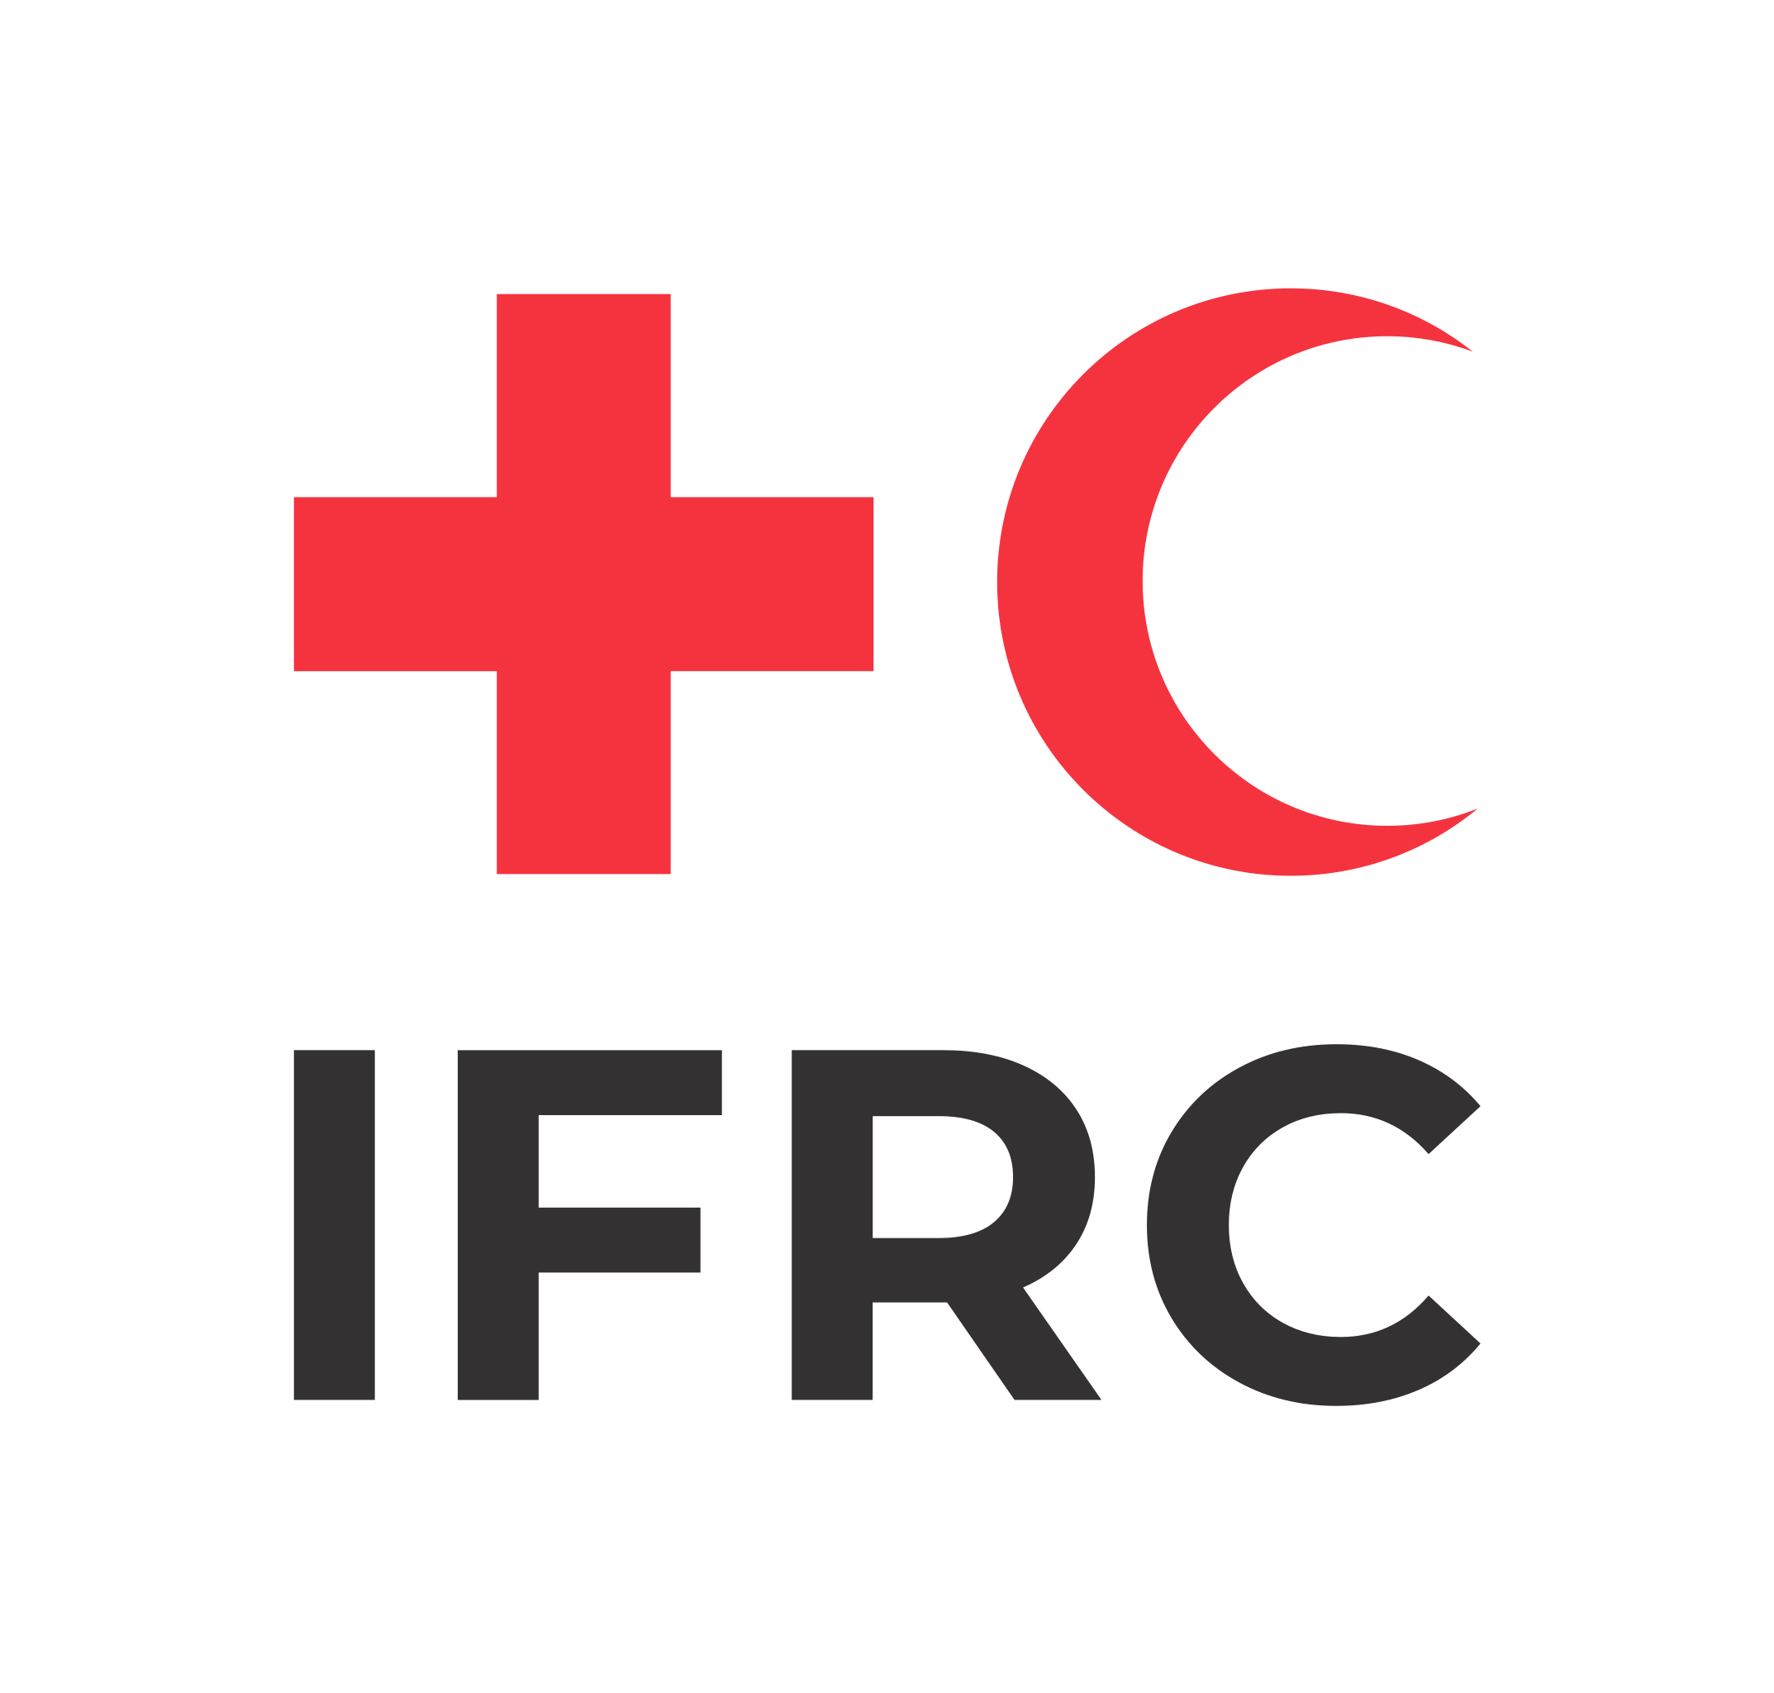

CHOLERA OUTBREAK:

Context [Last updated on 20th Feb 2023]
This live document aims to support Red Cross and Red Crescent National Societies and partners with key available thematic guides, tools, and resources on cholera. This document does not fully exhaust all cholera materials but intends to compile some of the most important ones to support different countries at field level.

Which tools and resources exist to help me implement core activities?
- Understanding the situation (context analysis):
- RCCE Collective Service context analysis tools
- Community Engagement and Accountability Tool 13 CEA in Assessment (section 2 – context analysis)
- RCRC Cholera Country Capacity Mapping
- Relevant questions for quick context analysis

- Rapid assessments and insights
- RCCE Collective Service compilation of a questions bank for assessments
- Community Feedback Database
- Cholera Question Bank
- Cholera basic Household questionnaire (in Kobo)
- Cholera rapid risk WASH assessment tools
- Cholera Standard Focus group discussion (FGD) (in Kobo)
- Cholera Treatment Unit/Centres (CTU-CTC) evaluation form
- Key cholera questions to be included during assessments
- Matrix for coordination of cholera control activities
- Rapid Anthropological Assessments in the Field
- Rapid Remote Context Analysis Tool (RR-CAT) in Epidemics

- Coordination and planning
- RCCE Collective Service coordinated planning guidance and tools
- Community Engagement and Accountability Tool 4 CEA Strategy Template
- IFRC social and behavioural change planning and guidance
- IFRC guidelines for planning hygiene promotion in emergency operations
- Epidemic Control Tookit – Cholera – for community volunteers
- Epidemic Control Toolkit – Cholera – for response managers
- Global Task Force on Cholera Control – Cholera Outbreak Response Field Manual
- Global Task Force on Cholera Control – Cholera app
- ICRC chlorine solution calculation app
- MSF management of a cholera epidemic guide

- Implementation
- RCCE Collective Service implementation and monitoring resources for cholera (Banque de question surtout)
- Social, behavioural and community dynamics related to the cholera outbreak in Malawi
- A collection of general cholera posters (US CDC)
- The story of cholera video
- Community messages | Epidemic Control Toolkit (ifrc.org)
- Universal cholera flipchart | English | French | Kiswahili
- Q&A for volunteers and field staff

- Learning and training resources
Learning
- Social Science in Action: Selected reports or briefs on cholera compiled by SSHAP
- Social Science in epidemics: cholera lessons learned
- Identifying transferable lessons from cholera epidemic responses by Médecins Sans Frontières in Mozambique, Malawi and the Democratic Republic of Congo, 2015–2018: a scoping review
Training
- BORT WASH (BTIT) training manual [previously BTIT]
- Branch Outbreak Response Training WASH for volunteers (BORT) [previously BTIT]
- Cholera Community Engagement Training Guide [An updated package is being developed]
- Epidemic Preparedness and response in Communities (EPiC) Training in EN and FR
- Oral cholera vaccine training for volunteers
- Oral Rehydration Point volunteer training (3 days)

Suggested Key Performance Indicators (KPIs) for cholera responses

This is a set of suggested key performance indicators (KPIs) for community-based public health operations in response to cholera outbreaks. KPIs are aimed at supporting a more structured approach to monitoring, quality assurance and evaluation. Indicators should be selected depending on the area that is supported in a given outbreak response; specific context needs; and available capacity to conduct the corresponding monitoring activities.
For a comprehensive overview, you can access our Key performance indicators for cholera control activities here
Which specific Risk Communication and Community Engagement (RCCE) activities should I consider adopting in my cholera response?

Risk Communication and Community Engagement Outcome:
People actively participate in controlling the cholera outbreak by promoting safe, healthier practices, facilitating community action, and helping to reduce fear, stigma, and misinformation.

Output 1: the response is based on a thorough understanding of community needs, priorities, and context, including preferred ways to receive information, participate and give feedback
Suggested activities:
- Carry out a context analysis and community mapping to understand the structures, groups, power dynamics, capacities, beliefs and challenges and needs
- Rapid community assessments to understand knowledge, attitudes, practices, and perceptions on cholera
- Train staff and volunteers in rolling out operational research (in coordination with partners)
- Community workshops to identify problems, brainstorm solutions, and agree activities and roles

Output 2: effective community engagement and behaviour change approaches to motivate action, promote participation and create an enabling environment for change
Suggested activities:
- Train staff and volunteers on community engagement, with focus on behaviour change and risk communication approaches
- Intensify community engagement with focus on strengthening community-led solutions to prevent and control the outbreak
- Provide funding grants and support to local community groups to implement local solutions
- Roll out trainings to ensure CEA is integrated across the response and staff and volunteers have the knowledge and capacity to engage communities
- Train and support local community groups, leaders, volunteers, and representatives to lead activities and behaviour change and risk communication approaches
- Scale up outreach activities to provide timely, accurate and trusted information and support to enable them to take action and protect their health and prevent the spread of infection
- Interactive social media, radio, and TV shows to encourage positive behaviours and safe practices, address rumours, fear, misinformation, and stigma
- Engage community members and groups in developing behaviour change and risk communication information and materials
- Adapt/translate information about cholera to the local context and languages

Output 3: Analyse, respond, and act on community feedback and social data about behaviours and use it to make changes and improvements to the response
Suggested activities:
- Set up the feedback mechanism, including systems for collecting, responding, analysing, sharing, and referring feedback
- Train all those involved in collecting and managing feedback on how the process will work
- Collect feedback from community volunteers about the beliefs, fears, rumour, questions, and suggestions in communities
- Regularly review programmes and activities as well as update the information shared with communities based on community feedback data and changes in the context
- Monitor how the feedback mechanism is working by analysing the volume of feedback received and who it comes from to ensure no one is being missed and it is working well
- Conduct regular FGDs to check the response is using the most effective channels, approaches, and languages to reach different groups and that information is received, understood, trusted and useful

General guidance on community engagement and accountability

The Red Cross Red Crescent Movement also has a wealth of guides, case studies, and training materials on community engagement and accountability including these key resources:
- The Red Cross Red Crescent Guide to Community Engagement and Accountability
- The CEA toolkit
- The IFRC Feedback Kit
- The Community Engagement Hub is a free online public platform, hosted by British Red Cross, with training packages and more than 300 tools, guides, and case studies on a range of topics from feedback mechanisms to radio programmes

For questions or support, please contact Sabrina Gehrlein, CEA delegate for Africa region: sarbrina.gehrlein@ifrc.org

