WHAT IS THIS TOOL?
This tool helps to determine the scale of the feedback mechanism you might be establishing. When considering the scale you need for your feedback mechanism, you have to think about the purpose of your feedback mechanism, who needs to see the feedback you will be collecting and the available resources.

WHAT DO WE MEAN BY "SCALE"?
The scale of a feedback mechanism refers to the geographic and organisational level(s) the feedback mechanism is operating on. A feedback mechanism can be limited to one local team or be as broad as an inter-agency feedback mechanism operating across several districts or even countries. A bigger scale of a mechanism does not erase smaller feedback loops on levels closer to the communities. Different scales of feedback:
- Local Level - Informs decisions on the local level which can be taken by the local team in coordination with local actors
- District/Branch Level - Informs decisions on the district/branch level which might be taken in coordination with partners on the branch level
- National Level - Informs decisions on the national level concerning the whole organisation or operation. Action might be taken in coordination with partners on the national coordination level.
- Inter-Agency or Regional Level - Informs inter-agency and/or regional decisions. Action might be taken in coordination with partners on the national and regional coordination level.

WHY DO WE NEED TO DETERMINE THE SCALE BEFOREHAND?
To start the planning process of your feedback mechanism, you need to be clear about who else will be involved in the process to make sure the data will be used and addressed. This will impact the resources you need and guide the next steps of mapping the flow of the feedback within your organisation or coordination structures with other partner organisations.

HOW TO USE THIS TOOL?
- Start with the first question of the decision tree below and follow the arrows according to your answers, which will lead you to the level relevant to your feedback mechanism.
- Go the table below the decision tree to learn more about the characteristics of a feedback mechanism operating on that level
- Continue the process of setting up or strengthening your feedback mechanism.

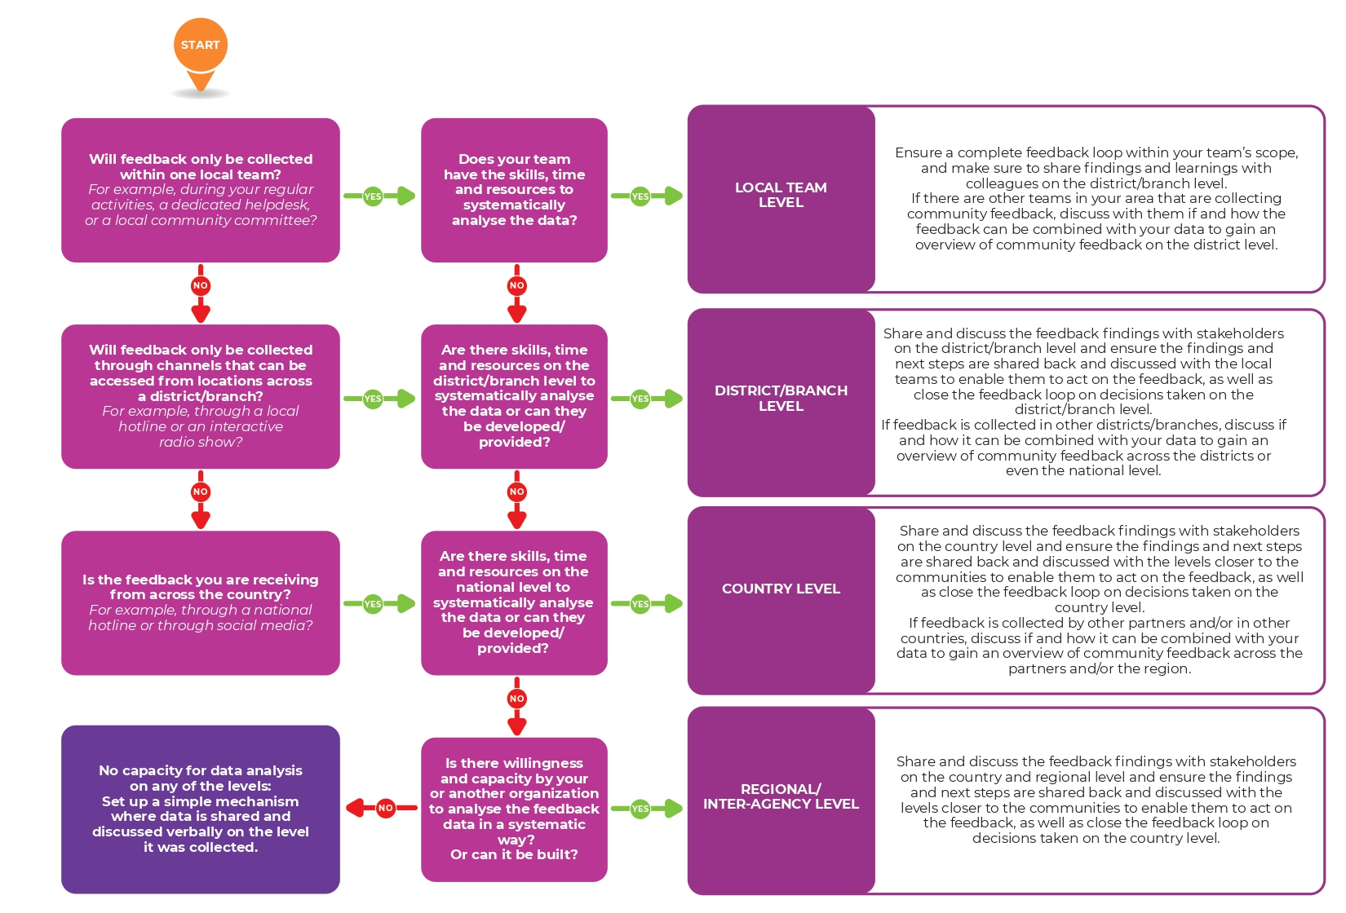

The table below provides an overview of the different scales of a feedback mechanism and what a feedback mechanism on that level looks like:

SCALE | PURPOSE | BEST USED? | LANGUAGE REQUIREMENTS | CONSOLIDATION | FEEDBACK ANALYSIS | SHARING OF FEEDBACK
Local Level | Informs decisions on the local level which can be taken by the local team in coordination with local actors. | If feedback is only collected in a small geographic area and concerning a small number of projects implemented by one team. | Feedback data can be documented, analysed and discussed in local language(s). | Feedback data can be consolidated verbally during regular meetings or added to a logbook or database managed by the local team. | Team meets regularly to discuss what was heard and determine actions. | Findings are shared with other local teams and other local stakeholders, including the community.
District/Branch Level | Informs decisions on the district/branch level which might be taken in coordination with partners on the branch level. It also supports analysis and action on the local level. | If feedback is collected by several teams working in one district/branch and an overview of the situation across the branch/district is needed. | Feedback data can be documented, analysed and discussed in local language(s) if these are understood by everyone in the analysis process. | Feedback data is transferred into an Excel logbook or uploaded to a central database if it was collected using mobile devices. | Data is coded and analysed systematically by a team on the district/branch level. | Findings are shared and discussed with all teams on the district/branch, and partners on the district level to advocate and coordinate joint action in response to the feedback.
National Level | Informs decisions on the national level concerning the whole organisation or operation, as well as supports analysis and action on levels closer to the communities. Action might be taken in coordination with partners on the national coordination level. | If feedback is collected in several districts/branches and an overview of the situation across the country is needed. | May require translation of feedback data into the national language if the local language(s) are not understood by everyone in the analysis process. | Feedback data is transferred into an Excel logbook which needs to be shared with the team on the national level or uploaded to a central database if it was collected using mobile devices. | Data is coded and analysed systematically by a team on the national level. | Findings are shared and discussed with all teams on the national level, and partners on the national level to advocate and coordinate joint action in response to the feedback.
Inter-Agency or Regional Level | Informs inter-agency and/or regional decisions. Action might be taken in coordination with partners on the national and regional coordination level. | If feedback is collected in multiple countries and/or by multiple organisations. This is particularly relevant during large-scale disasters such as pandemics or natural disasters affecting multiple countries. | Will require translation of feedback data into the language used on the national or regional level if the local language(s) are not understood by everyone in the analysis process. | Feedback data is transferred into an Excel logbook or uploaded to a central database if it was collected using mobile devices. | Data are coded and analysed systematically by a team on the regional level and/or a team tasked with response-wide analysis. | Findings are shared and discussed in inter-agency coordination meetings.

