WHAT IS THIS TOOL?
This tool helps to understand the different options you have for coding open feedback data for you to decide which option that fits your context and needs. The table below helps you to evaluate the advantages and disadvantages of each approach, and the following pages show visual illustrations of what four of the six options look like.

CODING STRATEGY | ADVANTAGE | DISADVANTAGE
Hand-written coding  See what this can look like here. | - Easy to set up and carry out  - Not reliant on technology, power, etc.  - Inexpensive | - Hard to consolidate and analyze for large amounts of data  - Greater chance of errors in consistency of coding  - Generates lots of paper to store
Flipcharts, whiteboards, blackboards  See what this can look like here. | - Easy to set up and carry out  - Not reliant on technology, power, etc  - Inexpensive  - Encourages conversations around coding | - Hard to consolidate and analyze for large amounts of data  - Greater chance of errors in consistency of coding  - Harder to store and access data (e.g. storing large flipcharts or photos of blackboards)
Word processing document  See what this can look like here. | - Easier to store larger amounts of data | - Requires access to and training on computers  - Dependent on electricity  - Some chance of inconsistency of coding  - Still some challenges in consolidating and organizing large amounts of data
Excel or other electronic database  See what this can look like here. | - Easier to store and organize very large amounts of data  - Drop-down menus help consistency of coding  - Built-in sorting and analytical capacity | - Requires access to and training on computers  - Dependent on electricity  - Requires training in software like Excel
Qualitative analysis software  See what this can look like here. | - Easier to store and organize very large amounts of data  - Software helps with consistency of coding  - Built-in sorting and analytical capacityA | - Requires access to and training on computers  - Dependent on electricity  - Requires budget for software like NVIVO or MaxQDA  - Requires training in software  - More difficult to automate visualizations
Machine learning software  See what this can look like here. | - Easier to store and organize very large amounts of data  - Coding happens quickly and automatically  - Built-in sorting and analytical capacity | - Requires access to and training on computers  - Dependent on electricity  - Requires advanced training on artificial intelligence and machine learning

EXAMPLE OF HOW FEEDBACK COMMENTS CAN BE CODED IN A WRITTEN LOGBOOK:

Date Place Demographic Comment Code
Why are you vaccinating my children again? I thought you people already come through here last month and did a vaccination. Why another one?
Question: vaccines
1/24 District 3 Adult woman

The tools that were given out as part of the livelihoods program have already broken.
Complaint: livelihoods program
1/24 District 4 Adult man

Thank you for the radio program you did about dengue. The younger generations don’t remember how bad it can get but I remember when we had a bad outbreak twenty years ago…
1/25 District 5 Elderly man
Complement: radio program, health education

I’ve been hearing rumors that if we sign up for this program, the government will get our names. I don’t want the government to know I am a part of this program.

Rumor: cash program

1/25 District 5 Young man

EXAMPLE OF HOW FEEDBACK COMMENTS CAN BE CODED ON A FLIPCHART:
Questions: vaccines
Why do children need another round of vaccines?
What kinds of side effects will the vaccines give us?
How is this vaccine different than the one you came with six months ago?
Who made this vaccine? Why should we trust them?
I heard the vaccines will make you really sick.
I saw something on WhatsApp that the vaccines have poison in them.
My cousin said we are getting faulty vaccines that the rich countries don’t want
Rumors: vaccines
How can we wash our hands if our community doesn’t have good water?
Thank you for the soap you gave us, but I don’t think I can afford to buy this soap after it runs out.
In the rainy season, we have trouble getting to the borehole to get water.
Concerns: WASH program
EXAMPLE OF HOW FEEDBACK COMMENTS CAN BE CODED IN A WORD PROCESSING PROGRAMME:
Background information | Comment | Code
District 3, Jan 24, Adult woman | I really don’t understand why you keep talking to me about vaccinating my children. They’ve already had two vaccines this year. Why do they need another? | Question: vaccines
District 3, Jan 24, Adult woman | I’ve heard that the NGOs make money on these vaccines. I feel like this is why you keep coming back to vaccinate my children. | Rumor: vaccines
District 3, Jan 24, Adult woman | I think you should bring that mobile clinic back. It makes me feel like you actually care about my children’s health, not just about whether they get this vaccine or not. | Suggestion: health programming
District 3, Jan 24, Adult Man | I really appreciate the new farming program. It has been a long time since an NGO helped us with our farms. | Appreciation of activities: livelihoods program
District 3, Jan 24, Adult Man | But you know, it started too late in the season. We’ve almost missed all of the good rains already. | Issue with timeliness: livelihoods program
District 4, January 25, adult man in wheelchair | I can’t get to the community meetings during the rainy season because the roads get too muddy and my wheelchair gets stuck. | Barriers to access: person with disability

EXAMPLE OF HOW FEEDBACK COMMENTS CAN BE CODED IN EXCEL OR ANOTHER ELECTRONIC DATABASE:
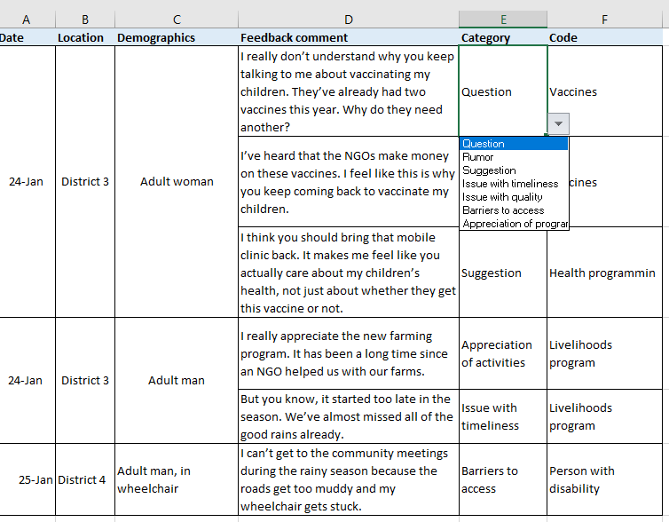

EXAMPLE OF HOW FEEDBACK COMMENTS CAN BE CODED USING A QUALITATIVE ANALYSIS SOFTWARE:
