WHAT IS THE PURPOSE OF THIS TOOL?
This tool helps you to think through where the information generated in your feedback mechanism will go. This process will help ensure the feedback cycle will be complete and everyone involved will receive the information that is relevant to their responsibilities. It also helps to make sure that once action is taken, the feedback loop will be closed both internally, and externally with communities and other involved stakeholders.

HOW TO USE THIS TOOL?
- Gather all the information you have collected as part of the previous steps to set up a feedback mechanism. This includes information that helped you to decide on the scale of your feedback mechanism (see more in this tool), and the information you collected when defining the communication channels (see more in this tool).
- Go to STEP 1 to determine who needs to be part of the mapping process
- Go to STEP 2 and organise a meeting with the key stakeholders where you will review how you will receive the information, where what kind of information needs to go, and how.
- Go to STEP 3 to make sure all participants have access to the output of the meeting
- Continue the process of setting up the feedback mechanism by agreeing on roles, responsibilities and timeframes by using this tool.

STEP 1: DETERMINE WHO NEEDS TO BE PART OF THIS PROCESS
You need to get together with the key people who need to be involved in the process to create buy-in with your colleagues and leadership. Who this is will depend on the scale of your feedback mechanism. It is anyone on whose involvement and support the feedback process will depend on. It will likely include:
- Leadership
- Programme and operations staff
- Information Management
- Monitoring and Evaluation
- Human Resources
- PGI
- Security

STEP 2: ORGANISE A DISCUSSION WITH THE KEY STAKEHOLDERS
Organise a discussion as part of a dedicated meeting, a workshop, or training. Ideally, this is part of a workshop for setting up the feedback mechanism, here is the agenda for such a workshop. If this is not feasible, at least make sure to do the below exercise and share the suggested mapping with those key stakeholders and organise bilateral meetings for follow-up where necessary.
Document the discussion on a flipchart or a shared document if the meeting is conducted online.

1. Discuss the answers to the following questions:

Through which channels are we receiving information from the communities?
Review the information related to the types of feedback channels that you collected during previous steps (using this tool to define the communication channels) and ask your colleagues to confirm or add additional information. Here is a reminder of the questions:
- Which channels are we currently using to share information, receive feedback, and respond to communities?
- Are there structures managed by the community or other partners that we can use?
- Are these channels suitable and working?
- Do we need additional channels?

WHAT kind of information will you receive?
Discuss the types of information you will receive from communities. Review the types of information mentioned below, and make sure everyone has the same understanding.

Operational feedback - This is feedback that directly relates to ongoing projects, programs, activities, or operations that are being undertaken by the organization.
This might include anything related to the operation or the specific programme that the relevant sectors or roles need to discuss. Sometimes this feedback can be addressed on the spot and other times it helps to monitor trends and discuss with different stakeholders to decide which changes are needed in your programmes or interventions. For example, this can be suggestions on changes of the schedules for distributions, questions about opening hours, or reports of dissatisfaction with the type of assistance provided.

Big-picture feedback - This is feedback about issues that fall outside of your specific projects or interventions and is often about strategic issues or broader challenges with the response efforts.
It might have to do with the context or changes in the community and may not be actionable for your team. For example, this can be discontent with the Government, questions about the end of the disaster, or comments about the role of women in their community. It is important to track this information as well, as it helps to understand the community and enables you to share findings with others who might be in the position to address specific issues.

Some of the operational and big-picture feedback might have to be treated separately and /or urgently, depending on its sensitivity and criticality:
Sensitive Feedback – Any information that can put the person sharing it or other people linked to it at risk and needs to be handled with care.
This can involve serious allegations related to breaches of national or international law, or human rights law concerning the protection (safety, dignity, and rights) of affected populations, or any violation of the humanitarian Code of Conduct or safeguarding policies. Sensitive feedback can be received as any type of feedback, such as report, a question, or a suggestion as it depends on the specific situation if it puts a person at risk if shared with others.

Critical feedback – Any feedback that requires urgent/timely follow-up.
These can include issues like the delivery of spoiled food, potential security risks, signs of an outbreak of disease, or new rumours in the community that might directly threaten upcoming programming. Critical feedback comments need to be shared immediately with the person in the best position to address the comment.

WHO needs to see that type of information?
Go through the different types of information and discuss who should see this information. The output of this discussion will be your referral framework. Add sub-categories where needed. Document the discussion on a flipchart or a shared document.

Following guiding questions help you develop your referral framework:
- Which technical sectors does the operational feedback refer to?
- Who of your colleagues is best placed to act on feedback relating to these sectors?
- If you don’t have a colleague, which other partners or stakeholders can you share the feedback with?
- Does the operational feedback require individual follow up?

WHAT | WHO
Operational feedback
Big-picture feedback

2. DRAW the information flow, taking into account:
- how the information is collected
- where it will be saved
- who the different types of information need to be shared with
- where this information will be discussed
- how the feedback loop will be closed with the community

The information flow can look something like the following – but might look completely different. Just make sure it captures the different steps comprised in a complete feedback cycle.
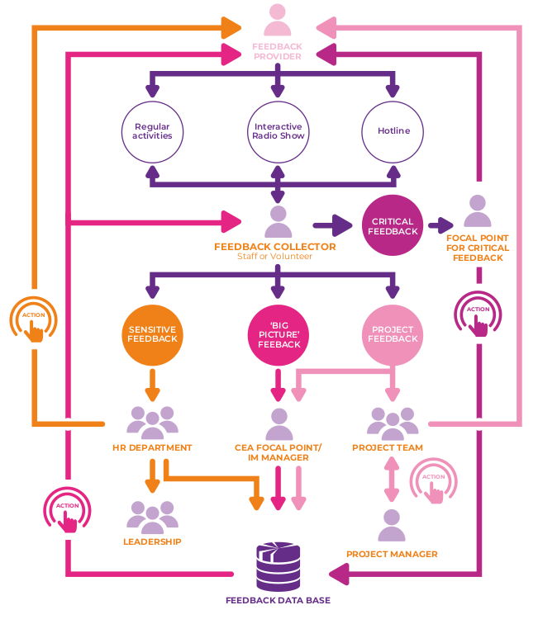

Which avenues can be used to share this information?
Now that you know where the information needs to go and you have started to develop your referral framework, you can discuss how the information will be shared with the different focal points. Think about the information carriers, as well as how often the information is shared.
- How is information currently shared within the organization?
- Are these avenues suitable for the different types of information?
- How to best share the information in the future?

This information can be added in the third column of your table:
WHAT | WHO | HOW
Operational feedback
Big-picture feedback

STEP 3: SHARE AND APPROVE THE DOCUMENTATION OF THE WORKSHOP
At the end of the workshop, make sure the flowchart and the tables you filled in are shared with all workshop participants. The finalised and approved versions will guide staff and volunteers involved in the feedback process and need to be discussed in trainings.

Inter-Agency Standing Committee (2021). Data Responsibility in Humanitarian Contexts. Operational Guidance, p.30.

