WHAT IS THIS TOOL?
This tool helps you to be clear about the options you have for documenting the open feedback you are or will be receiving through different feedback channels. For guidance and tools to identity the best feedback channels for your context, see “Stage 1 – Building your feedback mechanism” in the feedback kit.

HOW TO USE THIS TOOL?
- Start with the first question below and follow the arrows according to your answers, which will lead you to different options for how you document the feedback you receive.
- Go to the table below to learn more about the advantages and disadvantages of the different ways to document feedback data.
- Continue the process of setting up or strengthening your feedback mechanism as detailed in “Stage 1 building your feedback mechanism”.
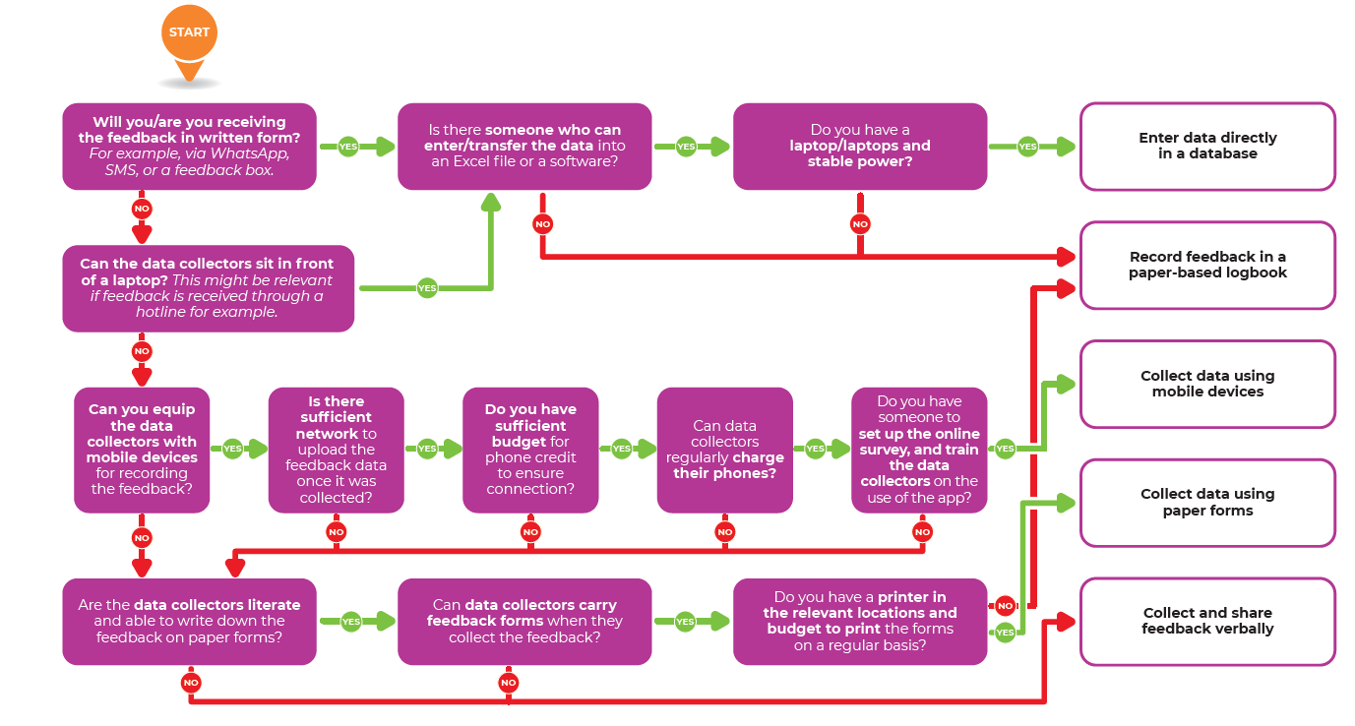

TYPE | ADVANTAGE | DISADVANTAGE
Collecting and sharing feedback verbally  Not recording the information in a systematic way, but sharing the main points in debriefs and weekly meetings | - No additional staff or resources are needed  - Easy to set up and integrate into ongoing meetings  - Not disrupted by power or internet outages | - Individual comments cannot be quantified and analysed in a systematic way  - Easy to forget details  - Difficult to share the feedback in the feedback provider’s words
Recording feedback in a paper-based logbook  All feedback comments are manually written down in a central paper-based logbook. | - Easy to set up  - Not dependent on special equipment  - Not disrupted by power or internet outages | - Difficult to share and analyse feedback  - Prone to human error  - More difficult to keep sensitive information safe and restrict access
Collecting data using paper forms  Carrying paper forms and recording the information when feedback is received | - Easy to set up  - Not dependent on special equipment  - Often easier to fill in for those documenting the feedback  - Not disrupted by power or internet outages | - Printing costs  - Costs time to enter the data to a database  - Prone to human error  - More difficult to keep sensitive information safe and restrict access
Mobile data collection  Using smartphones or tablet for recording the information | - Minimises human error  - Easier and faster to share feedback data  - Easier to keep sensitive information safe  - Many people already comfortable working with smartphones | - Need for smartphone and connection to upload data  - Vulnerable to power outages and mobile data service disruption  - Needs someone to set up the online survey, and train the data collectors on the use of the app
Entering data directly into database  Entering the information directly into the Excel file during the conversation, or when receiving the message | - Ideal for those sitting in front of a computer while receiving the feedback, e.g. call centre operators, during an interactive radio show, when documenting feedback received through WhatsApp  - Saves time as no extra step is needed to transfer the data to a database | - Only feasible if a laptop is available  - Requires staff to be computer literate and trained on data entry  - Vulnerable to power outages

