TOOL 14: CEA Case Study Template
This tool provides a template and guidance to write a CEA case study. For an example of a CEA case study using this template see: https://communityengagementhub.org/wp-content/uploads/sites/2/2020/04/CEA-in-CTP_Madagascar-Case-Study_DRC-IFRC-FINAL-1-1.pdf

CEA CASE STUDY TITLE
SUBTITLE – 2-3 line brief summary of the case study. Make sure it is clear, short and interesting. This is your chance to get the attention of your audience and ensure they read the full case study.

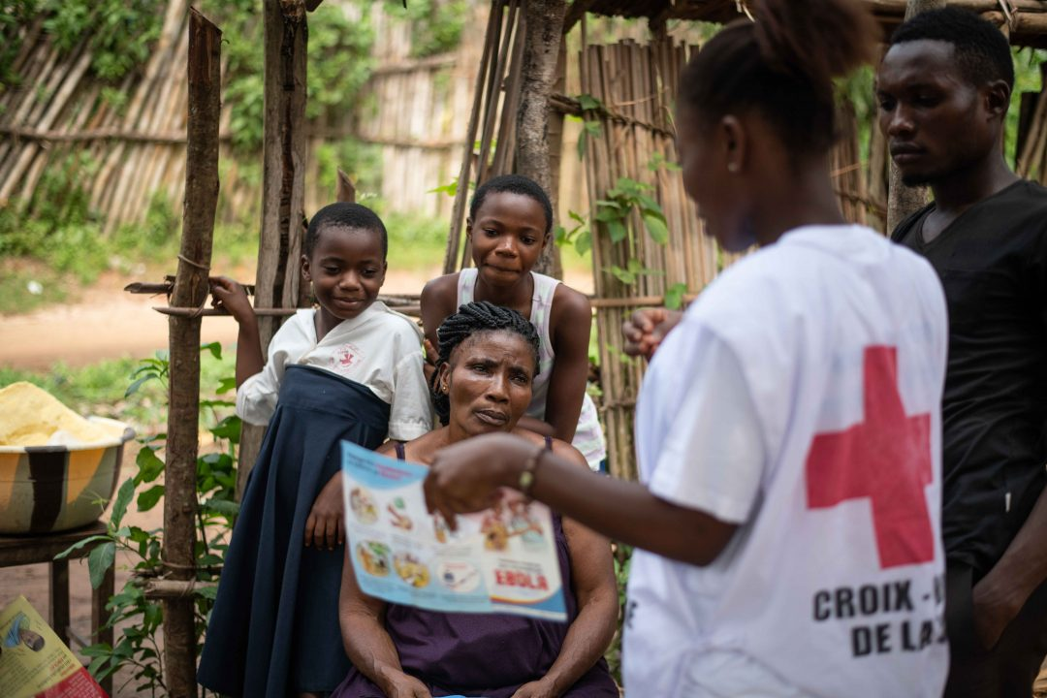
Introduction
Insert your own photo and add a photo caption (one sentence). The photo should provide Red Cross/Red Crescent in action while also showing the dignity of the people we serve. Please make sure the photo is following basic IFRC Photo Guidelines.

(approx. 200 words)
Provide a brief overview of the case study topic. Include:
- Country / location
- Dates
- Programme or emergency response discussed
- Any partners involved
- The challenge faced by the programme or operation
- How CEA helped to address this challenge

Community engagement approach
(approx. 500-2000 words, but depends on the issue being discussed)
This is the main body of the case study and should explain:
- The CEA approaches or activities used, how they were implemented and who was involved. For example, if your case study is about a feedback and complaints system you would explain here how you went about setting the system up, how the community were involved, how the feedback was collected, analysed and reviewed, how it was acted upon by the National Society and how responses were given to the community
- Why you chose these activities. For example, what challenge or problem within the community, programme or operation did they address
- The impact community engagement approaches and activities had on the programme, operation, and community
You can use photos, infographics and quotes from community members or other stakeholders in this section.

Lessons learned
(approx. 500 words)
What key lessons did you learn that could benefit other programmes, operations, or National Societies? Include positive and negative lessons learned – share both the successes and the things that didn’t work and should not be repeated.

Next steps
(approx. 200 words)
How will lessons learned from this experience be taken forward? How will community engagement approaches be further developed. Any final points or conclusions.

Contact information
For more information on this case study please contact:
Oganisation: Name, position, email, telephone number(s)
Oganisation: Name, position, email, telephone number(s)

