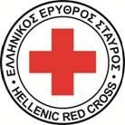
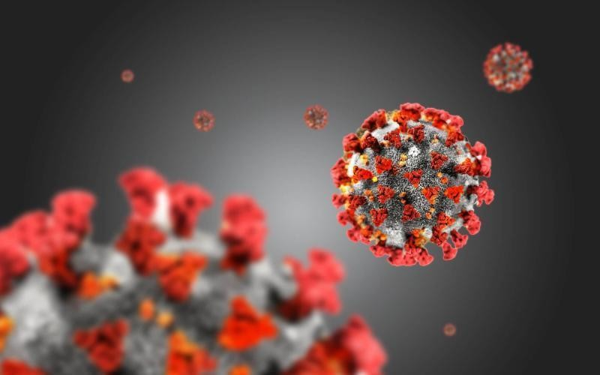
Community, Engagement and Accountability (CEA)

Survey on the migrant’s population information needs, regarding health issues (Covid-19)

A case study elaborated by the Hellenic Red Cross

Introduction 4
Survey goals 5
CONTENTS
Methodology 6
Survey results 8
Conclusions/Challenges 16
Main Points 17
Next steps 17

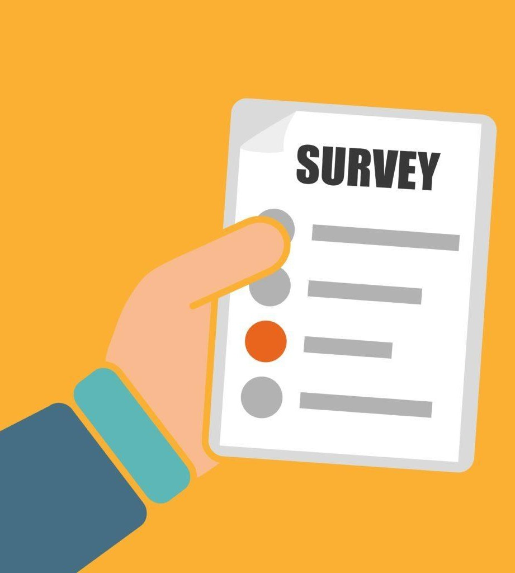

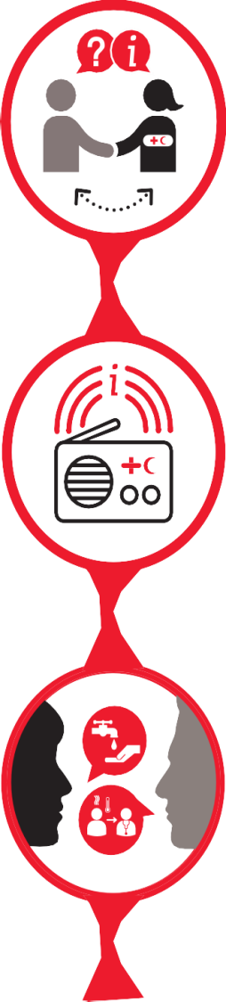
From the very beginning of outbreak, Hellenic Red Cross (HRC) has focused on the designing and the implementation of activities targeting on the provision of life-saving and timely information, regarding the measures of protection, the ways of transmission, the symptoms of Covid-19 etc, towards the migrant population. Main aim of the information campaigns was to enhance the target group skills towards the risks of misinformation, to minimize potential tensions in the migrant communities that would potentially be risen due to extended rumors and false information, to build a relationship of trust and active communication between HRC and migrant communities and finally to promote positive and safer health behaviors and practices.
Introduction

Particularly, the reliable and timely information on Covid-19 was provided through the creation and dissemination of relevant information material (posters, flyers, general guidelines), through the conduction of recreational activities, through face-to-face communication, personal and community meetings, focus group discussions and information sessions supported by specialized on health issues HRC staff. A very core element to the whole approach was also the use of the digital material & equipment (e.g TV screens, Hotline, Kobotool).

CEA is the process and commitment of providing timely, relevant and actionable life-saving and life- enhancing information to communities. It is about using the most appropriate communication approaches to listen to communities’ needs, feedback and complaints, ensuring they can actively participate and guide Red Cross/ Red Crescent actions.
Community, Engagement and Accountability (CEA)

CEA supports those involved in programmes and operations to adopt innovative approaches to better understand and engage with people and communities and help them address unhealthy and unsafe practices. It maximizes the Red Cross Red Crescent’s unique relationship with the community to help them speak out about the issues that affect them and influence decisions and policy-makers to implement positive changes.

One of the most basic needs that arises from the Covid- 19 pandemic, is the provision of relevant, timely and reliable information regarding general information and safe practices on Covid-19, which the migrant population should follow and adopt. The above need goes along with the necessity of continuously updating the relevant information according to the new scientific data that are available regarding Covid-19.

HRC, in parallel, has also taken into consideration the migrants’ vulnerability on having access to the information as aid and at the same time the difficulties that are facing in order to receive and fully understand the information provided to them by overcoming barriers, such as the language variations, the lack of interpretation etc.
Survey Goals

More specifically, the survey was targeting on:

- The collection of timely and updated information regarding the migrant’s information needs and gaps they may have on health issues and particularly in Covid-19

- The measurement of the migrants’ attitude towards the existence of Covid-19

- The migrants’ preferences on the communication channels (where from they receive information regarding Covid-19? Which
channels they trust the most? What information networks they use?)

- Investigate the emotions caused by the Covid-19 pandemic (fear, insecurity?)

- Gaining more information on general issues that the migrants population is concerned and need additional information

The basic aim of the survey was to discover, understand and point out the most appropriate and relevant ways and methods of the HRC respond on addressing the migrants’ information needs and also adjusting, updating and altering the already existing methodology of providing timely Covid- 19 information as aid, based on the migrants’ feedback and needs.

In future steps the survey would aim in the design and creation of printed material that would include information on Covid-19, based on the feedback provided and collected form the migrant communities.

Finally, the survey is aiming to work as a tool in order to obtain more information on how we can protect the migrants from misinformation regarding Covid-19, ignorance, stress and insecurity and at the same time to come with new ways and ideas on how to build on their self-confidence by avoiding of being victims of misinformation.

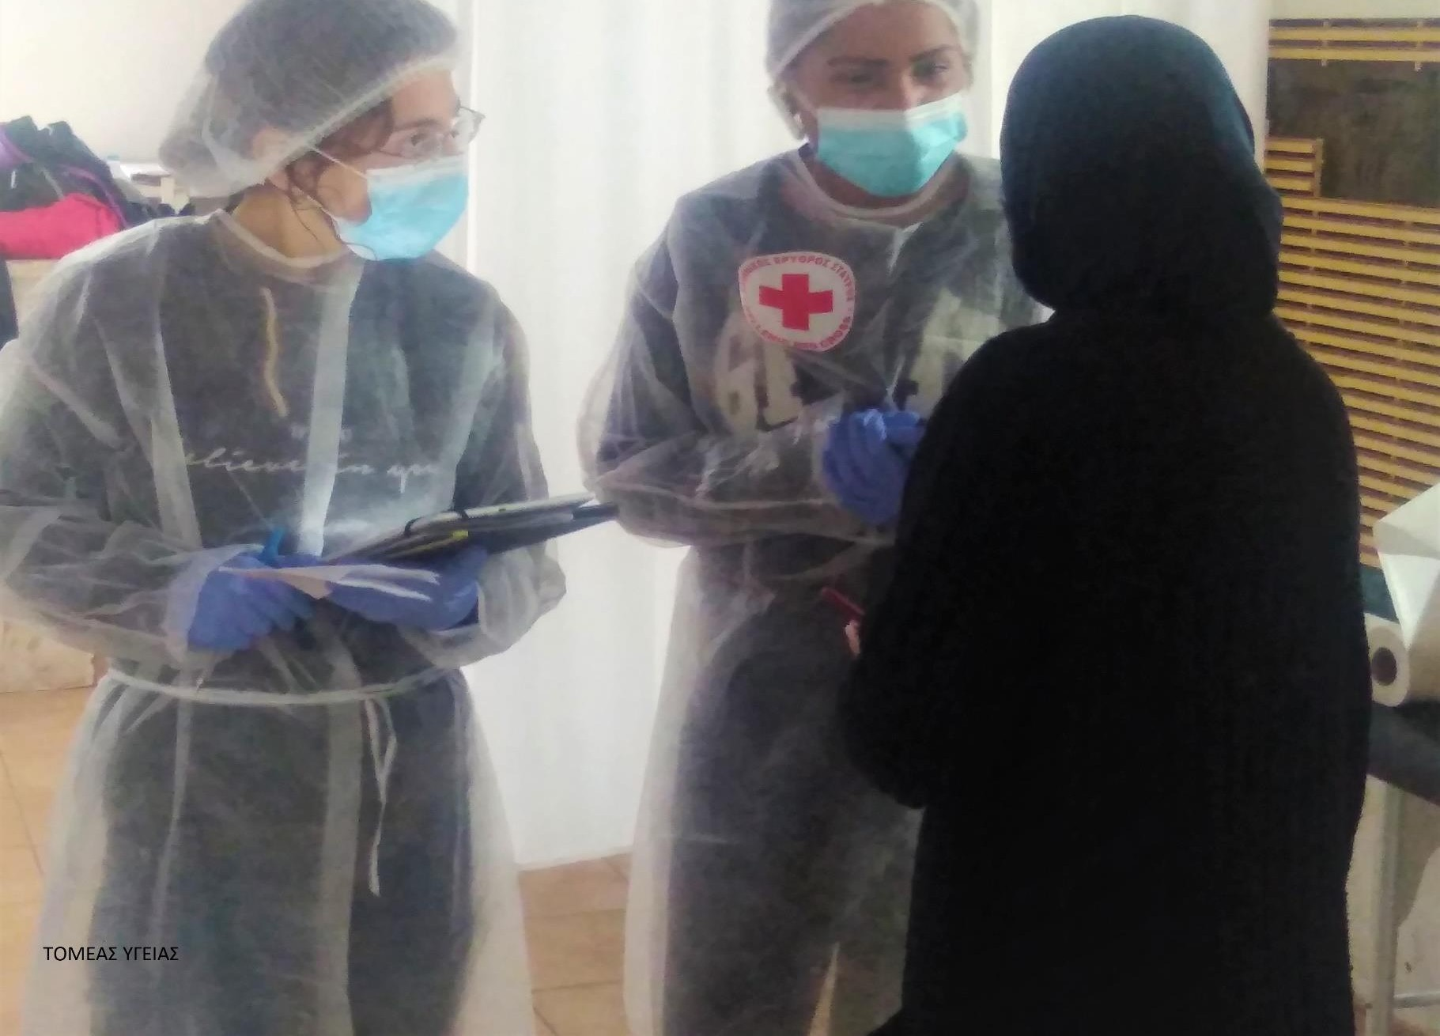

The survey was carried out between 7-18 of December 2020 (2 weeks’ duration) and the method of receiving feedback was through the provision of a questionnaire, using Kobotool. The target group was the migrant and refugee population of diverse gender, nationality and age group that were recipients of the HRC delivering services (the survey addressed to the 10%-15% of the population of each program).

The questionnaire was formed through a series of collaborations and meetings between the staff of the HRC Health Division and the Coordinators of the survey, that were targeting to designing a relevant questionnaire upon the survey needs. In order to reach to an adjusted questionnaire towards the respondents’ general profile and special characteristics, it was agreed that the final questionnaire should be short, consistent and would include questions that would be formulated in a simple and comprehensive language.
Methodology

In total, the questions were seven (7) aiming to explore the beliefs regarding Covid-19 attitudes and beliefs. The survey was conducted by the field staff (interpreters, health staff, coordinators, psychologists and social workers) that had access to the migrants and communicated with them in a daily basis.

It was conducted in the five (5) HRC Unaccompanied Minors Shelters (Athens, UMA shelter A and B, Kalavryta and Volos), in the Educational Health Station of Athens and Kallithea, in the refugee camps of Malakasa, Kleidi (Serres), Korinthos and Lesvos, in the ACCREF (Accompaniment & Referral) program, in the Mobile Health Unit 1 and in the Multifunctional Centers of Athens and Thessaloniki.

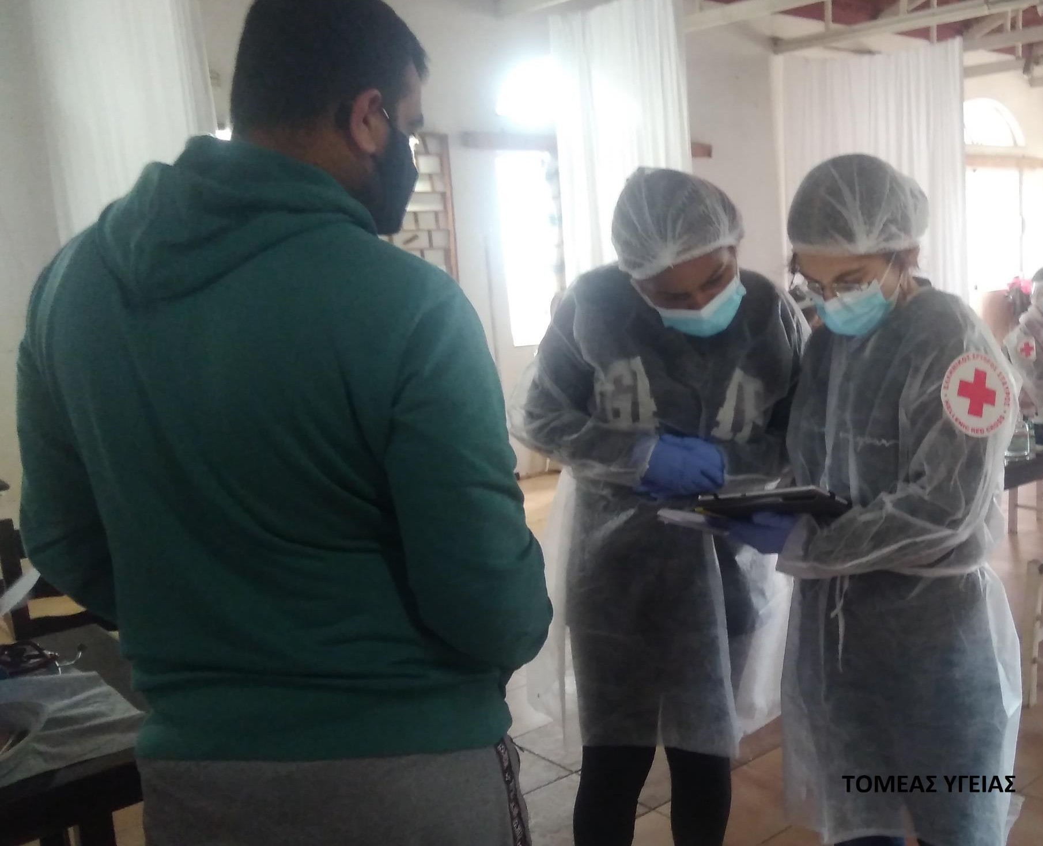

The elaboration of the questionnaire was supported by the HRC IT department and was originally inserted to the Kobotool. Relevant and detailed instructions regarding the use of kobo were shared to all the HRC staff that would participate in the survey. The “Kobotool information package” included:
- Guidelines on how to conduct the survey
- Guidelines on how to use and download the Kobotool
- Guidelines on how to fill up the Kobo form

In those cases, where the participants weren’t familiar with the Kobotool, additional training meetings were held by the survey focal persons in order to explain and provide technical support on how to use successfully the tool. When the survey was finalized, the statistical representation of the results disseminated to all the focal persons and later on a focus group discussion (FGD) that took place, targeting in pointing out and analyzing the results, key factors and potential difficulties that were raised during the survey conduction. More particularly the FGD aimed at:
Methodology

  - Receiving general feedback from the HRC staff who conducted the survey (Did it go well? Anything noted?)
  - Identifying and registering the challenges that made the whole process more difficult and pointing out those issues/factors that contributed positively to the surveys conduction
  - Discussing and analyzing the results
  - Brainstorming on the next steps and designing of a plan of action, regarding the life-saving information provision on Covid-19 issues, based on the survey results

The questions were formulated taking consideration the purpose and the aims of the surveys and were framed in a simple language, using comprehensive words and terms so as to be understandable by all the participants, even from those with high level of illiteracy and those coming from a different cultural context.
-In the survey in total participated 353 refugees and migrants, out of whom 196 (55,52%) were men and 156 (44,19%) women. The majority of the responders (54,67%) were between 25-45 years old. A percentage of about 20% was 18-24 years old, 54 of the participants were minors, while only 10% was over 45 years old and only one participant was over 60 years old.
-The majority of the answers was coming from persons that visited the HRC Education Health Station of Athens (18,41%), from the RIC in Kleidi (Serres, 17,28%) and from ACCREF program (15,01%).
-The majority of the participants were originated from Farsi speaking countries (37,68%), Arabic speaking countries (37,71%), French speaking countries (16,15%), English speaking countries (7,65%), Kourmaji speaking countries (1,98%) and Somali speaking countries (1,42%).
-11,9% the interviewees answered that they don’t believe that Covid-19 exists and 52,69% believed in the Covid-19 existence.
Survey Results
-42,21% said that they get informed regarding Covid-19 from internet (webpages, blogs), 30,03% from social media (facebook, Instagram etc), 17,56% from face-to-face communication, 8,78% from TV, 5,38% from Hotlines and 4,82% from radio.
-To the question about what additional they would like to know about Covid-19, 34,28% required more information about preventing measures, 32,01% about Covid-19 symptoms, 23,51% about ways of Covid-19 transmission.
-63,17 of the interviewees hasn’t heard any rumors regarding Covid-19 and 36,53% has heard.
-On the question regarding which way they’d prefer to get informed on Covid-19, 41,93% answered from internet, 30,88% from face-to-face communication (community meeting, door-to-door information sessions etc) and 16,16% from printed material (posters, flyers etc).
-30,31% said that the main feeling they have got from the Covid-19 pandemic is fear, 17,56% anxiety, 15,58% sadness, 11,09% interest and curiosity and 18,13% indifference and anger.
-Also, 18,7% said that would like to know more about vaccination issues, 15,86% about chronical diseases, 23% about family orientation issues and contraception and dermatological infections and 11,62% about scabbies and lices issues.
-With regard to rumors circulating in communities about Covid-19, it has been observed that the most widespread rumor is that this disease does not exist and that the existence of Covid-19 is a lie. Also, many admitted that they had heard rumors that the virus was manufactured by humans and by governments. There was also a high frequency of rumors that the virus is deadly and that anyone who gets stuck dies.
The statistical representation of the answers is the following:

8

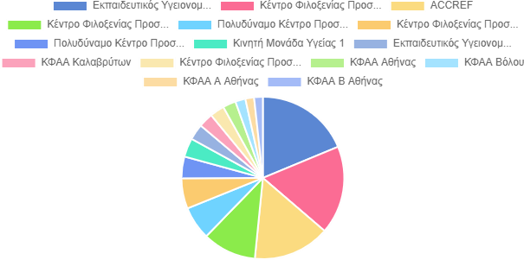
9
Structure/Program/Service

 |  | Percentage
Value | Frequency
Educational Health Station (EHS) Athens | 65 | 18.41
Refugee Camp (Serres) | 61 | 17.28
ACCREF (Accompaniment and Referral Program) | 53 | 15.01
Refugee Camp Korinthos | 37 | 10.48
MultIfunctional Center Athens | 23 | 6.52
Refugee Camp Malakasa | 21 | 5.95
MultIfunctional Center Thessaloniki | 15 | 4.25
Mobile Health Unit 1 | 13 | 3.68
Educational Health Station (EHS) Kallithea | 11 | 3.12
Unaccompanied Minors Shelter Kalavrita | 10 | 2.83
Kara Tepe RIC (Lesvos) | 10 | 2.83
Unaccompanied Minors Shelter Athens | 9 | 2.55
Unaccompanied Minors Shelter Volos | 7 | 1.98
Unaccompanied Minors Shelter Athens A’ | 6 | 1.7
Unaccompanied Minors Shelter Athens B’ | 6 | 1.7

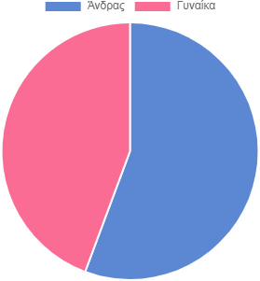
Gender
TYPE: "SELECT_ONE". 352 out of 353 respondents answered this question

Value | Frequency |  | Percentage
Men | 196 |  | 55.52
Women | 156 |  | 44.19

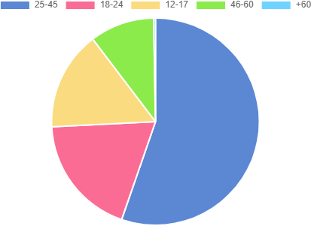
Age
TYPE: "SELECT_ONE". 349 out of 353 respondents answered this question

Value | Frequency | Percentage
25-45 | 193 | 54.67
18-24 | 66 | 18.7
12-17 | 54 | 15.3
46-60 | 35 | 9.92
+60 | 1 | 0.28
 |  |  | 10

Languages
228 out of 353 respondents answered this question.

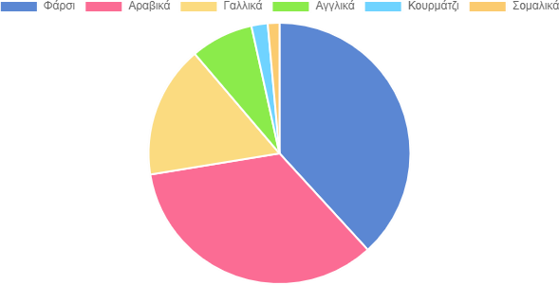

Answer | Frequency | Percentage
Farsi | 133 | 37.68
Arabic | 119 | 33.71
French | 57 | 16.15
English | 27 | 7.65
Kurmaji | 7 | 1.98
Somali | 5 | 1.42

t o
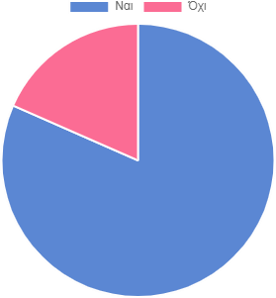
Answer | Frequency | Percentage
Yes | 186 | 52.69
No | 42 | 11.9

u g h
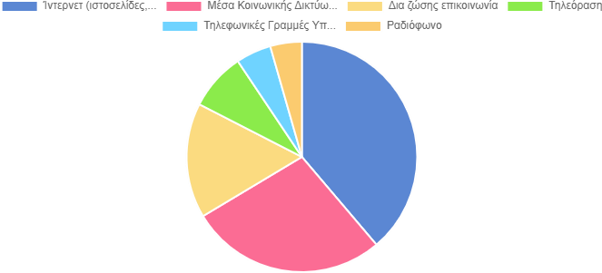

228 out of 353 respondents answered this question.

Answer | Frequency | Percentage
Internet (sites, blogs) | 149 | 42.21
Social Media (Facebook, Instagram) | 106 | 30.03
Face to face communication | 62 | 17.56
Television | 31 | 8.78
Telephone helplines (hotlines) | 19 | 5.38
Radio | 17 | 4.82

What else would you like to know about Covid-19;
219 out of 353 respondents answered this question.

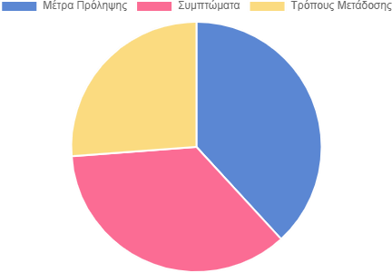

Answer | Frequency | Percentage
Prevention Measures | 121 | 34.28
Symptoms | 113 | 32.01
Transmission Modes | 83 | 23.51

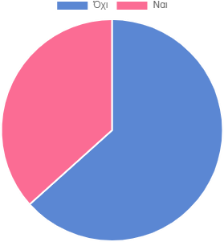

Answer | Frequency | Percentage
Yes | 129 | 36,54
No | 223 | 63,17

How would you like to be informed about Covid-19;
227 out of 353 respondents answered this question.

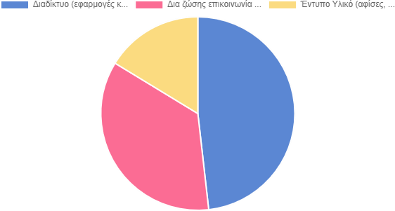

Answer | Frequency | Percentage
Internet (apps) | 148 | 41.93
Face -to -face communication | 109 | 30.88
Printed matter (booklets, posters, brochures) | 50 | 14.16

How the Covid-19 pandemic makes you feel?
225 out of 353 respondents answered thisquestion.
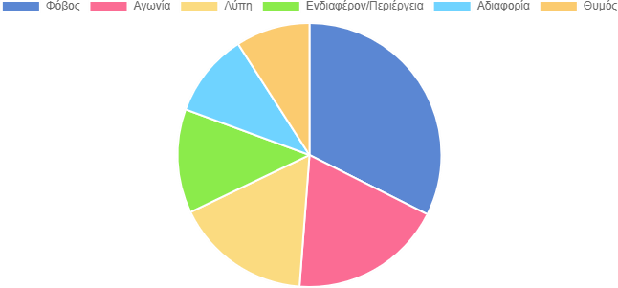

Answer | Frequency | Percentage
Fear | 107 | 30.31
Agony | 62 | 17.56
Sadness | 55 | 15.58
Interest/Quriousity | 42 | 11.9
Indifference | 34 | 9.63
Anger | 30 | 8.5

On which additional health issue would you like to get more information?
TYPE: "SELECT_MULTIPLE". 172 out of 353 respondents answered thisquestion. (181 were without data.)

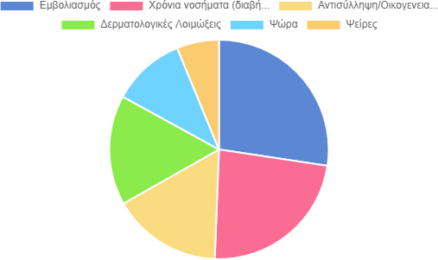

Answer | Frequency | Percentage
Vaccination | 66 | 18.7
Chronical diseases (diabetes, hypertension, heart disease, etc.) | 56 | 15.86
Contraception / Family Planning | 39 | 11.05
Dermatological Infections | 39 | 11.05
Scabies | 26 | 7.37
Lice | 15 | 4.25

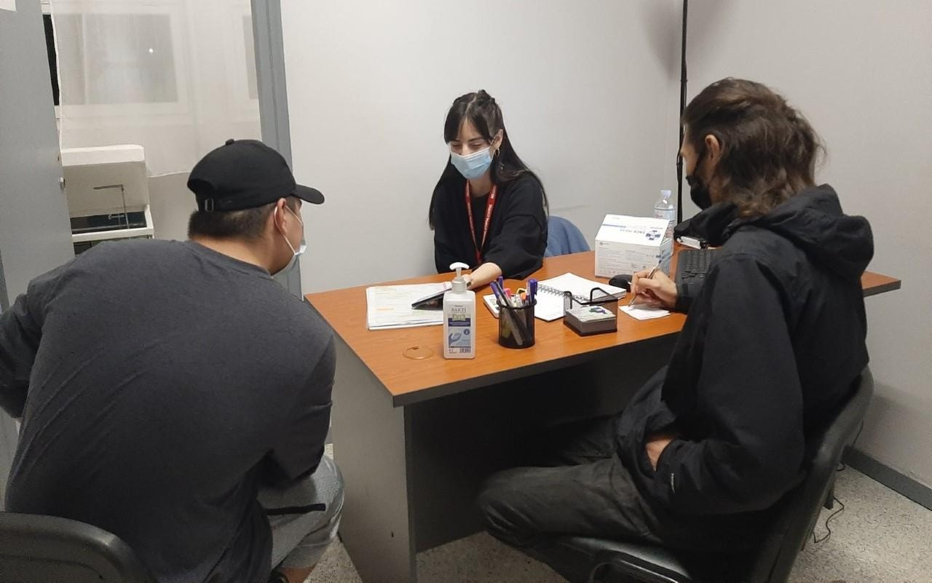

During the conduction of the survey and based on the results of the focused group discussion meeting with the participation of the staff who supported the survey, the followings were observed:

- A large proportion of respondents seemed not to understand the question regarding rumors and in many cases examples of what we mean by "rumors" had to be given. Also, the recording of the answers in the Kobotool sometimes appeared to be a difficult task for the interviewer, as the respondent's extended answer had to be summarized in one or two lines

- It was noted that when asked if Covid-19 exists, many respondents did not understand the question, so that an explanation was needed from the interviewer. The answer 'I do not know/do not answer' should also be added in the original questionnaire in order to record these answers as well
Conclusions/Challenges

- The majority of survey respondents were eager and cooperative in participating in the survey and answering the questions

- The time given to carry out the survey (2 weeks) was considered to be insufficient as it coincided with the Christmas period and staff holidays

- Some of the HRC staff used Kobotool for the first time, which took them longer to deal with the application (e.g. downloading, to get familiar with, etc.), but without mentioning serious difficulties while using the tool

- Not all languages, e.g. Bengali or Urdu, were included in the questionnaire, so it was not possible to be recorded

- The fact that some questions were of a closed type (e.g. only three options given) and there the option "other" was not available, limited the recording of additional answers, as many participants had something different to reply apart from the 3 options originally given to them

- In the Mobile Health Units (Malakasa) it was observed that a percentage of refugees was not able to participate in the survey, since they were visiting the clinic in a state of stress. This factor seemed to affect their ability to participate in the survey so the interviewers had to “scan” and address to those who seemed fine and willing to take part on the research.

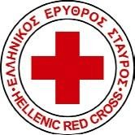
Next steps
Main Points

- The conduction of this survey contributed substantially to an interactive communication between the target population and the Hellenic Red Cross, building at the same time on acceptance, confidence and trust. In addition this survey turned out to be a useful methodological tool of CEA and a good practice through which the migrant population was approached with interest, in order to collect information on the needs and gaps regarding the adequacy of the information on Covid-19.

- The most widespread rumor in the migrant communities about Covid-19 was that there is no specific disease, the existence of Covid-19 is a lie and Covid-19 is a fatal disease. Taking into consideration the rumors that have been captured by the survey and the feelings of stress and fear they may cause, it’s essential to build on the lack of information and fake news and promote through the right use of communication channels, relevant and accurate information regarding Covid-19.

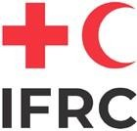

This research contributed to the collection of useful information on the perceptions of the migrant population with regard to Covid-19 and thus contributed to the creation of an action plan as well as to the adaptation of methods of providing targeted information to the migrant population. More specifically:

- It was proposed to update the Public Health Guide by adding information about Covid-19 (available services, clinics, hospitals, etc.)

- Taking into consideration the surveys finding that the main source of receiving Covid-19 information is internet, it was proposed to inform the migrant communities about trustworthy websites, links which contain valid and reliable information on Covid-19

- It was suggested to combine the communication channels and methods (e.g. dissemination of printed material together with live information sessions) in order to achieve a high level of accurate information provision.

- The information messages on Covid-19 should be applicable to all the migrant population (e.g both to minors and elder population, to those who can’t read, both to those who live in a camp and those who live in an urban setting), by taking also into account their profile, special characteristics.

