Community Feedback Update

Community Engagement & Accountability (CEA)

National Society: xxx
Feedback collected between xxx and xxx
Feedback channels used: xxx
Total feedback: xxx (xx women and xx men)
Average time to respond to feedback:
Status: xx open, xx referred, xx closed

Community data:
"Why don't you kill all the bats? It's to have money when Ebola comes back." (man, 29 - 39years, Beni)
“Why aren't children vaccinated, since they are more exposed to the disease?” (woman, 40-49 years, Mangina)
…

Analysis
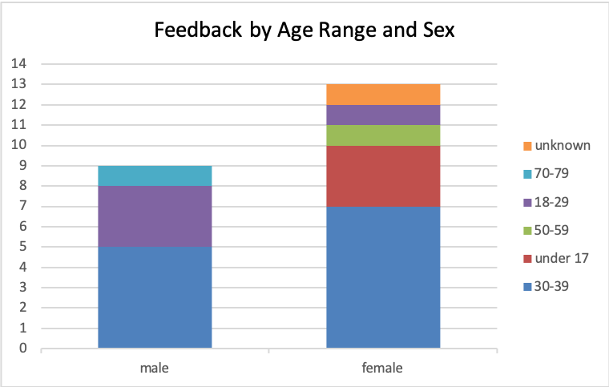
Figure 1 feedback age and sex wise n=22
EXAMPLE TEXT:

Overview:
In the reporting period of xx to xx we received a total of xx feedbacks from xx women and xx men (see figure 1). Most feedback was related to xx sector and concerned topics of x y and z (see figure 2).
Gender, age and vulnerability:
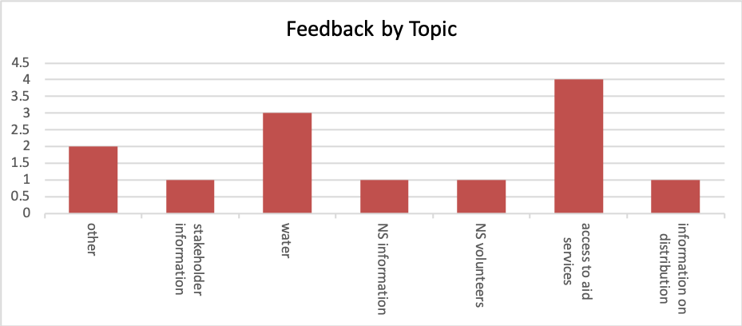
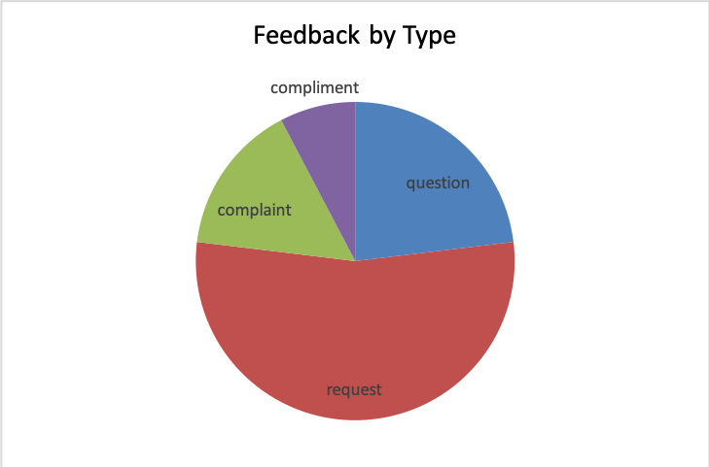
Figure 3 Feedback given by women n=13
Figure 2 Feedback given by women n=13
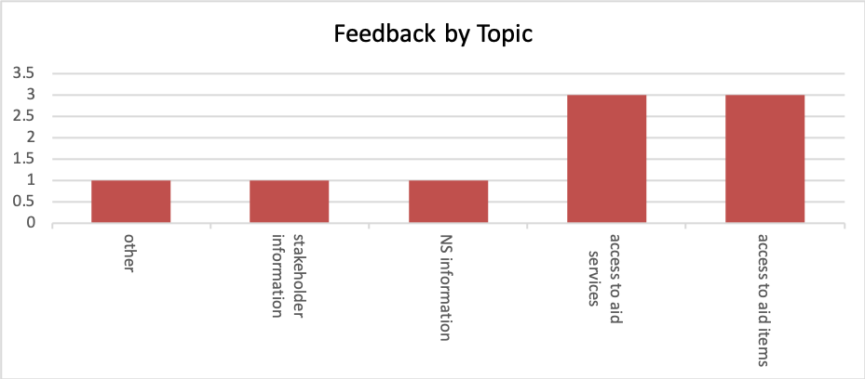
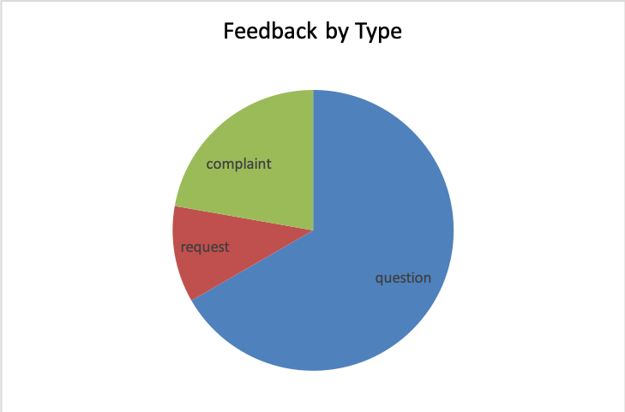
Figure 5 Feedback given by men n=9
Figure 4 Feedback given by men n=9

While women mainly had requests, that concerned water and access to aid services (figure 2 and 3) in particular requests for more xyz. Men mainly asked questions about how to access aid services and aid items (see figure 4 and 5). Key questions men wanted answers to were x, y and z.
When comparing feedback age wise there is a clear difference between age group x and age group y in key topics. Between women and men there are the following differences.
X person that are classed as vulnerable gave feedback and it mainly concerned xzy.

Challenges:
A major challenge during the reporting period has been xyz.

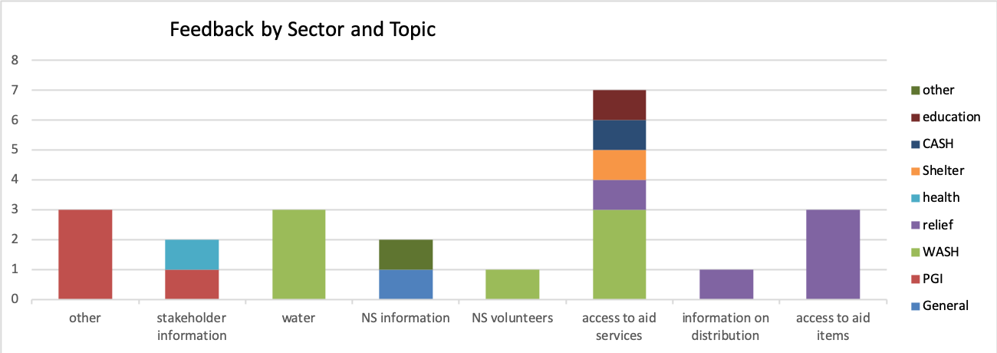
Figure 4 key topics according to sectors n=22

Recommendations and relevant links:
- EXAMPLE: community data shows that we have not received many feedback from women over 50. It is recommended to include public cooking spaces in the camp as a location to collect feedback and complaints in order to make sure their views are included in the feedback mechanism.
- Link to other resources etc.

Contact:
CEA officer name
Office
E-mail address

